Endowment vs. Previous Preferences: Which Cue Drives Consumer Decision-Making?

Anna Katharina Spälti*, Mark J. Brandt*, and Marcel Zeelenberg*†
*Tilburg University
† Vrije Universiteit Amsterdam

Author’s Note
Anna Katharina Spälti, Department of Social Psychology, Tilburg University; Mark J. Brandt, Department of Social Psychology, Tilburg University; Marcel Zeelenberg, Department of Social Psychology, Tilburg University, and Department of Marketing, Vrije Universiteit Amsterdam.
Correspondence concerning this article should be addressed to Anna Katharina Spälti, Department of Social Psychology, Tilburg University, 5000 LE Tilburg, the Netherlands. Email: a.k.spalti@uvt.nl
This research did not receive any specific grant from funding agencies in the public, commercial, or not-for-profit sectors.
Data and materials are available on the Open Science Framework (OSF) under https://osf.io/k5cq9/?view_only=14ef12422d8e4b6594167c05af0cb218
Acknowledgements
We thank Paul van Kemenande for his help in obtaining the smartphones used in Experiment 1 and for his help with data collection in the lab.

Highlights
- The endowment effect does not happen in a vacuum
- Previous preferences in favor of or against an endowed product can attenuate or boost the endowment effect respectively
- Both previous preferences and endowment affect memory retrieval order which in turn predicts choices

Abstract
Research on the endowment effect has shown that simply endowing people with a good can increase the salience of the good and make it more likely to be chosen over alternatives. Other lines of research suggest that previous preferences are hard to override and may be chronically accessible to decision makers. We investigate the relationship between previous preferences (i.e. brand loyalty and purchasing habits) and the endowment effect in a switching paradigm and measure participants’ memory retrieval orders to assess the salience of choice options. In Experiment 1 (N = 202), participants interacted with a smartphone of a brand either in line with or contradicting their brand loyalty. We find that participants high in brand loyalty are most likely to be influenced by the experimental condition than those low in brand loyalty. In Experiment 2 (N = 486), we endowed participants with a can of Coke or Lipton and measured their purchasing habits of these products. We find main effects of both endowment and purchasing habits. In both experiments, the salience of cues was affected by both previous preferences as well as endowment. We show that the endowment effect is not completely immune to previous preferences: It can be weakened for people with (strong) previous preferences in favor of an alternative option or boosted for people with (high) previous preferences in favor of the endowed option.

Keywords: previous preferences, endowment effect, query theory, consumer decision-making, brand loyalty

Endowment vs. Previous Preferences: Which Cue Drives Consumer Decision-Making?
The endowment effect is characterized by people placing higher values on products they own or were endowed with, compared to when they had not been endowed with the product (for an overview see Morewedge & Giblin, 2015). They value the coffee mug in their hand more than the coffee mug on the store shelf. In short, people seem to overvalue what they have. This preference for the current product is an example of the status quo bias wherein people make decisions that maintain the current state of affairs (Bar-Hillel & Neter, 1996; Moshinksy & Bar-Hillel, 2010; Samuelson & Zeckhauser, 1988). However, to have a product in hand is not the only relevant cue when making a purchasing decision. People may also have prior experience with the product. For example, they might identify with the brand, habitually purchase the product, or have fond memories of the product. These other experiences may serve as alternative cues within the current state of affairs. We test what consumers choose when faced with multiple cues and how these cues may alter the decision-making processes underlying the choice. In two experiments, we investigate how people make choices when self-reported previous preferences (i.e. brand loyalty and purchasing habits) and endowment overlap or contradict each other.
Endowment effect vs. previous preferences
Choices and preferences are reference-dependent (Bhatia, 2017). Reference- dependent theories of choice posit that when decision makers make a choice between (multiple) options they will use the most salient option or attribute as their reference point. Simply by changing this reference point, choices and preferences can be altered because the salient options and attributes shift. A classic example of reference dependent choice is the status quo bias. People are more likely to stick with the option that represents the current state of affairs (Samuelson & Zeckhauser, 1988). This can manifest in not acting to change the current state of affairs (e.g., endowment effects and default effects) or actively choosing an option that represents the status quo (e.g., incumbency advantage in politics). Previous research has shown that simply labeling one option as the status quo can shift preferences towards that option (Moshinksy & Bar-Hillel, 2010). However, little research has explicitly examined how people react when two strong decision cues are pitted against each other. Which decision cue becomes dominant in the decision-making processes? How does this decision-making process relate to actual choice?
One of the most well-known manifestations of a status quo is the endowment effect. It was first coined by Kahneman, Knetsch, and Thaler (1990) as an explanation of the lack of evidence for the Coase Theorem in real world markets. Coase Theorem describes how, within a market, products will (re-)allocate themselves to the consumers with high preferences for that product, assuming that the transaction costs are low. However, the endowment effect showed that people who are endowed with an object value that object more than those who are not endowed with the object. The endowment effect has been tested and consistently replicated in two experimental paradigms (Morewedge & Giblin, 2015). In the valuation paradigm, half of the participants are randomly endowed with a good (e.g., a mug) and then are given the opportunity to sell the good to the other half of the participants. The minimum amount of money that participants endowed with the mug are willing to accept to sell the mug (WTA) is much higher than the maximum non-endowed participants are willing to pay to acquire the mug (WTP). In the exchange paradigm, participants are randomly endowed with one of two goods. Participants are then given the opportunity to switch to the other good. However, participants are more likely than expected by chance to keep the good they were initially endowed with, even though the transaction costs for switching are low or even zero.
Cognitive process models suggest that attention and memory biases explain the effectiveness of endowments (Bhatia, 2017; Johnson, Häubl, & Keinan, 2007; Morewedge & Giblin, 2015). Here the argument is that the having or being endowed with an object becomes the status quo and acts as the reference point. The endowed good is more salient to the decision maker in the decision-making process than the other choice options. The positive (and negative) attributes of the endowed object will be remembered and assessed first as well as weighted more heavily in the decision-making process, leading to a preference for the endowed object. These memory and attentional biases can account for multiple explanations of the endowment effect, including loss aversion and psychological ownership (Morewedge & Giblin, 2015). The strong evidence for the endowment effect and how it shifts attention during the decision-making process, lead us our first hypothesis: the endowment hypothesis predicts that participants will opt for the endowed option, regardless of any previous preferences. This should also be reflected in participants’ decision-making processes, as the endowment of a product makes it more salient to the participant in the moment of making a choice.
However, the endowment effect is usually tested in settings where participants do not have strong pre-existing preferences or where pre-existing preferences were not measured. That is, participants are typically endowed with a relatively neutral object like a coffee mug or a chocolate bar. In real-word decision-making people may already have a preference for one of the products within the choice set, because of previous experience with the product or because of positive associations with the product’s brand. This may either be a previous preference for the endowed option, so that previous preferences and endowment are compatible, or a product other than the endowed option, so that previous preferences and endowment are incompatible. One example of including compatible previous preferences in an endowment experiment found that participants in a valuation paradigm were willing to pay more money for a mug with their college insignia pictured on it than for a plain white mug (Tom, 2004).
The option that represents the pre-existing preference and its attributes should become most salient to the decision maker during the decision-making process. On example of how a relative robust status quo bias can be overridden by a more relevant decision cue was provided in the context of political decision-making. The incumbency advantage, whereby citizens typically prefer candidates who are already in office, was completely overridden when candidates’ political ideology was made known (Spälti, Brandt, & Zeelenberg, 2017). This suggests that when strong beliefs are incompatible with the status quo, voters will opt for the focus on the cue in line with their previous preferences in the decision-making process.
Generally, it seems unlikely that consumers will opt for a good that is not in line with their pre-existing preferences, even if this good was endowed to them. Pre-existing strong preferences may be hard to shift (Morewedge & Giblin, 2015) and may be chronically accessible and exceptionally salient to decision makers, and thus take on the role of a reference point rather than an endowed object. As such, previous preferences may have the power to override the endowment effect, especially if these previous preferences have been held for a long period of time by the decision maker (Strahilevitz & Loewenstein, 1998). This leads us to our second hypothesis: 2) The previous preference hypothesis predicts that participants will choose the option in line with their previous preferences because the preferred option is chronically available to them and is therefore the salient reference point.
Nonetheless a third possibility arises. Participants may be affected by both previous preferences and endowment. Particularly for consumers with weak previous preferences or even negative experiences with the alternative choice option, endowment may become the dominant cue in the decision-making process. Thus, explaining both the robustness of the endowment effect but also not discounting the power of previous preferences. As such our preference strength hypothesis predicts that only consumers who have weak previous preferences will exhibit an endowment effect, while participants with strong previous preferences will opt with the choice in line with their previous preferences.
Query theory: Memory retrieval in favor of the status quo
Choice options that are most salient to decision makers are most likely to be chosen. This is in line with information processing accounts of decision-making which focus on how information is sampled, retrieved, and integrated during the decision-making process (Oppenheimer & Kelso, 2015). Information about salient options is more central to the decision-making process. Using query theory (Johnson et al., 2007), a theory about how information is retrieved from memory and integrated when constructing preferences, we aim to gain a better understanding of which cue within the current state of affairs (i.e. endowment or previous preference) is most salient to decision makers during their decision-making process. Query theory predicts the following process: First, people access preference-relevant information from memory by posing evaluative questions, or queries, to themselves in sequential order. Second, salient and easily-accessible information is retrieved earlier, is richer, and more numerous, and thus more heavily weighted in the decision-making process. Third, according to the principles of output inference and retrieval inhibition (Anderson, Bjork, & Bjork, 1994; Anderson & Spellman, 1995; Dempster, 1995), earlier queries interfere with the retrieval of other relevant information. Later queries are inhibited and less information is retrieved, leading these to be less predictive than earlier queries.
Based on the second premise of query theory, we can identify which decision cue is most salient to a decision maker by measuring which choice option is recalled first and most frequently in the memory retrieval process during decision-making. Previous research has successfully applied query theory to the endowment effect (Johnson et al., 2007) and default effects (Dinner, Johnson, Goldstein, & Liu, 2011) showing that the option considered the status quo is the most salient in the decision-making process. However, in a decision in which a more context-relevant cue (i.e., political ideology) was presented to decision makers, queries in favor of the context-relevant cue were retrieved earlier in the memory retrieval sequence regardless of which option was given the status quo label (i.e., political incumbent; (Spälti et al., 2017). This indicates that the most salient option to decision makers can shift depending on the cues present in the choice set and this shift is reflected in decision makers’ memory retrieval orders.
Using insights from query theory, we investigate which cue is most salient to consumers and thus acts as a reference point in the decision-making process: the endowed option (endowment hypothesis), the option corresponding to previous preferences (previous preferences hypothesis), or the reference point differs for decision makers with weak or strong previous preferences (preference strength hypothesis). By assessing which choice option was retrieved earlier in the memory retrieval process, we can make inferences about the salience of different decision cues within the current state of affairs. In two experiments, we provide participants with a choice set in which one of the options acts as an endowment. We then measure previous preferences (Experiment 1: brand loyalty; Experiment 2: purchasing habits) to investigate whether participants will choose the endowed good or if they are more likely to switch. Additionally, we measure participants’ query order during their decision-making process, to gain insight into which decision cue is most salient thus acting as the reference point and predicting decisions.
Operationalization of previous preferences: Brand loyalty and purchasing habits
In the context of consumer decision-making, a popular measure of previous preferences for consumer goods is captured by brand loyalty measures. Brand loyalty is defined as “the biased, behavioral response, expressed over time by some decision-making unit, with respect to one or more alternative brands out of a set of such brands, and is a function of psychological […] processes” (Jacoby & Chestnut, 1978, p. 80). Brand loyalty leads consumers high in brand loyalty to value and identify more with their preferred brand compared to alternatives (Chaudhuri & Holbrook, 2001). Loyal customers will continue purchasing products by their preferred brand, even if potentially better options are available to them (Jacoby & Kyner, 1973), and are willing to pay higher prices for products from their preferred brand (Krishnamurthi & Raj, 1991). Indeed, brand loyalty is often fostered by companies to ensure a consistent client base.
Of note here is that brand loyalty is described as a psychological process, or preference, which leads to behavioral outcomes. As such brand loyalty is generally measured in two ways: 1) attitudinal measures and 2) behavioral measures (Mellens, Dekimpe, & Steenkamp, 1996). The attitudinal measures usually refer to self-reported preference and commitment towards that brand. The behavioral measures are usually captured by aggregate data, market shares, or measures individual choices and/or purchasing patterns in favor of a specific brand (Mellens et al., 1996). In our experiments, we aim to capture both aspects by conceptualizing previous preferences in terms of self-reported brand loyalty and commitment towards a brand (Experiment 1) and self-reported purchasing habits of a brand (Experiment 2). For both experiments, we report all measures, conditions, data exclusions, and how we determined our sample sizes.
Experiment 1: Smartphones
In our first experiment, we investigate the effect of being endowed with a smartphone for a short time compared to the effect of brand loyalty on smartphone preferences, using both a hypothetical and incentivized measure of smartphone preferences. We measure whether participants endowed with a phone in line with their previous preferences (compatible condition) or contrary to their previous preferences (incompatible) exhibit differing choice patterns and memory retrieval processes. This will give us insight into how people go about making these decisions and help us measure which decision cue is most salient to the decision maker. Finally, we also include the additional measure of psychological ownership of the endowed smartphone for exploratory purposes. Psychological ownership has been proposed as a potential mechanism underlying the endowment effect (Morewedge, Shu, Gilbert, & Wilson, 2009).
Method
Participants. We aimed to recruit as many participants as we could during a period of one week. As we only had three smartphones available for our research, we could only test three participants at one time. After one week, we had recruited a total of 204 Tilburg University students to participate in our laboratory estudy. In return for participation, participants were awarded course credit or €5 cash. Additionally, one participant won a Beats by Dre headset (approximate value €130) in a raffle which participants could voluntarily participate in. We removed the data of 2 participants who did not own a smartphone at the time of data collection, which resulted in a final sample of 202 (64 women, 138 men, M_{age} = 20.87, SD_{age} = 2.60). To determine which effect size we could detect with this final sample, we conducted a sensitivity analysis with G*Power (Faul, Erdfelder, Buchner, & Lang, 2009). Specifically, we measured the ability to detect an increase in explained variance in our regression model by including an additional predictor. With our final sample, we would be able to detect an effect size of f = 0.20 with a power of 80%.
Procedure. The experiment was conducted using Qualtrics survey software. Participants completed the experiment on computers in our laboratory facilities. After providing informed consent, participants were asked about their general smartphone brand preferences and which brand of smartphone they currently owned. They also indicated how long they owned their current smartphone, how happy they were with their smartphone, and completed a brand loyalty measure towards the brand of their current smartphone. Next, participants were asked to imagine that they were about to buy a new smartphone and were debating between the newest iPhone, HTC, and Samsung models. Before deciding which of these three smartphones they would purchase, participants were given the opportunity to handle one of the three smartphones (depending on the experimental endowment condition). Participants were then asked to list all the thoughts that passed through their mind while considering which smartphone they would chose, before indicating their smartphone preferences, willingness to pay for each smartphone (WTP), and self-coded their thoughts. Finally, participants filled in a perceived ownership scale of the smartphone they had interacted with and provided demographic information (i.e., age, gender). Before being debriefed, participants were informed that they could participate in a raffle whose winner would win either the smartphone of their choice or a headset by Beats by Dre, and thus they were asked to indicate which of the three smartphones they would wish to win. The experiment was conducted in Dutch.
Primary measures.
Current phone. Participants were asked to type the name of the brand of their current smartphone. Next, they were asked for how many months (ranging from 1 to 48+ in one-month increments) they had been using their current phone and how happy they were with their current phone on a scale from 1 (extremely happy) to 7 (very unhappy), with a midpoint of 4 (neither happy or unhappy).
Brand loyalty. To measure brand loyalty towards their current phone, we asked participants to respond to four items regarding the brand of their current smartphone. “I intend to rebuy and continue using [phone brand]”, “It is difficult for me to change to from one smartphone brand to another”, “I believe that that [phone brand] smartphones have a higher quality than any other brand”, “I will continue to use [phone brand], even though I know that there were better alternatives” (α = .75). Participants indicated how much they agreed with each statement on a seven-point Likert scale from 1 (completely agree) to 7 (completely disagree) with a midpoint of 4 (neither agree nor disagree).
Scenario. Participants were asked to imagine themselves in the following situation:
“Today is the day you can renew your mobile phone subscription. After having used your current smartphone for two years, you decide to choose a new smartphone with your new subscription. You went to the local phone retailer to get some information about the newest smartphones. You received information about the newest iPhone, Samsung, and HTC smartphones. Subsequently you are handed one the smartphones. The salesman lets you use this smartphone. After using the smartphone, you will have to decide which smartphone you will choose with your new subscription.”
Below this description, participants are shown three pictures of the available three smartphones in randomized order: Apple iPhone 6s Plus, Samsung Galaxy S6 Edge Plus, and HTC One M9. At the time of data collection these were the newest smartphones of each brand on the market.
Brief endowment. After reading the scenario, participants were informed that there was a small box underneath the desk with a smartphone inside of it. Depending on the experimental endowment condition (iPhone, Samsung, or HTC), the box contained the corresponding phone. Participants were instructed to remove the smartphone from the box and use it as they would normally use a smartphone for the next few minutes: “[…] feel free to surf on the internet, take photos, or use or download an app”. They were told that after a few minutes the survey would allow them to continue. After five minutes, a green button would appear on the computer screen for the participant to continue to the next page of the survey, where they were informed to place the smartphone back in the box. On average, participants remained on this page, interacting with the smartphone, for 5 minutes and 26 seconds (SD = 43.32 seconds).
Compatibility. For purposes of the analysis, we classified participants according to compatible and incompatible conditions. Participants who were endowed with a smartphone of the same brand that they currently owned (e.g., a participant who owned an iPhone and was placed in the iPhone endowment condition) were classified as “compatible” (n = 52). Participants who were endowed with a smartphone other than the brand they currently owned (e.g., a participant who owned an iPhone but was placed HTC endowment condition), were coded as “incompatible” (n = 150). All analyses were completed using this compatible vs. incompatible classifications.
Aspect listing. To measure participants’ query order, we employed the aspect listing methodology (Dinner et al., 2011; Ericsson & Simon, 1984; Johnson et al., 2007), in which participants were instructed to list all the reasons that passed through their minds while considering which of the three smartphones they would purchase in the scenario. They were asked to consider why they would prefer the smartphone they were endowed with over the other smartphones. After entering their first response in a text box, participants clicked the submit button to bring them to the next screen where they could list a second response. This process was repeated until participants indicated that they did not have any more reasons to list (M = 4.27, SD = 1.31, Range [2, 8]). As in previous work (Johnson et al., 2007), responses were limited to 200 characters and participants were not trained in advance.
Relative smartphone preference. Participants were asked to indicate how likely they were to choose each of the three possible smartphones (Apple iPhone 6S Plus, Samsung Galaxy S6 Edge Plus, or HTC One M9) on sliders from 1 (very unlikely) to 100 (extremely likely). To measure the effect of temporarily being endowed with the smartphone, we measured the relative preference between the endowed smartphone preference compared the average of the other two smartphone preferences. In this measure, positive scores indicate an endowment effect, negative scores indicate a preference for the non-endowed smartphones, and zero indicates indifference between the endowed and non-endowed smartphones.
Self-coding of aspect listing. Participants coded the reasons they listed in the aspect listing task (Dinner et al., 2011; Johnson et al., 2007), as either about the iPhone, Samsung, or HTC smartphone. They also indicated if each response was a positive or negative reason about the selected phone. We coded aspects as either in favor of the endowed option (e.g., a positive reason about the iPhone when endowed with an iPhone) or as about the non-endowed option, which included negative queries about the endowed option (e.g., a negative reason about the iPhone when endowed with an iPhone) and both positive and negative reasons about the non-endowed option (e.g., a positive/negative reason about the Samsung when endowed with an iPhone).
Query Order (SMRD). We measured query order with the standardized mean rank difference (SMRD) score (Johnson et al., 2007). This score reflects participants’ tendency to list reasons in favor of the endowed smartphone before negative reasons about the endowed smartphone or reasons (both positive and negative) about the non-endowed smartphones. It is defined as 2(MR_{Endowed} – MR_{Non-endowed})/n, where MR = median rank of reasons for choosing the endowed or non-endowed smartphone in the participant’s sequence and n = the total number of reasons in the participant’s sequence. The SMRD score ranges from -1 (all reasons in favor of the endowed smartphone were listed first) to 1 (all reasons against the endowed smartphone or in favor of a non-endowed smartphone were listed first). For participants who only listed reasons for one smartphone, the SMRD score was calculated by setting the median rank of the missing reasons to s + 1 and n = s + 1, where s = the total number of reasons listed by the participant. This ensures that such participants received an SMRD score of 1 when they only listed reasons in favor of the endowed smartphone and an SMRD of -1 when they only listed negative reasons about the endowed smartphone or reasons about the non-endowed smartphones.
Incentivized preference. We aimed to also measure what participants’ real preference for the smartphones would be outside of our hypothetical scenario by including an incentivized choice. We told participants that they could enter into a raffle with the prize of either the smartphone of their choice or a headset by Beats by Dre (approximate value €130). There would only be one winner of the raffle. Participants were informed that if they wanted to participate in the raffle, they must indicate which of the three smartphones they would like to win: iPhone, Samsung, or HTC. All participants participated in the raffle and the winner received the headset by Beats by Dre.
Secondary measures.
Perceived Ownership. To measure perceived ownership, participants were asked to what extent they agreed with the following three items (Peck & Shu, 2009) about the smartphone they had interacted with during the experiment (1 = completely agree, 7 = completely disagree; with a midpoint of 4 = neither agree nor disagree): “I feel the smartphone is mine”, “I feel a very high degree of personal ownership of the smartphone”, and “I feel like I own this smartphone” (α = .91).
General smartphone brand preferences. Participants were asked to respond to an item regarding their general preference of smartphone brands on a ten point-Likert scale: “Generally, do you prefer Apple or Android smartphones?” (0 = Apple, 5 = no preference, 10 = Android). If participants indicated a preference for Android phones (<5), they also responded to an item that was aimed to distinguish their brand preference of android phones: “In regards to Android smartphones, do you generally prefer Samsung or HTC smartphones?" (0 = Samsung, 5 = no preference, 10 = HTC). Analyses and results for this measure can be found in the online supplemental materials.
Results
Relative smartphone preference. To test the effect of brand loyalty (mean centered) and compatibility (incompatible = -1, compatible = 1) on the preference for the endowed phone, we ran a multiple regression analysis, F(3,198) = 57.75, p < .001, R² = 0.47. There were significant main effects of both brand loyalty, b = 6.25, SE = 1.88, p = .001, and compatibility, b = 23.84, SE = 2.43, p < .001. These main effects were qualified by a significant interaction, b = 10.37, SE = 1.88, p < .001, which supports our preference strength hypothesis.
We probed the interaction at +1 SD and -1 SD of brand loyalty, to test the effect of endowment for participants who were highly loyal to their current smartphone brand or had no strong loyalty to their current smartphone brand. We found that for participants high in brand loyalty (+1SD) the effect of the compatibility condition was larger, b = 37.17, SE = 2.97, p < .001, than for participants with low brand loyalty (-1SD), b = 10.50, SE = 3.83, p = .007. This suggests that for people who are high in brand loyalty, being endowed with a phone of the brand they are loyal to boosts their preferences above and beyond mere endowment (Figure 1, left). However, if they are endowed with a smartphone incompatible with their brand loyalty, they are very unlikely to prefer that endowed smartphone. For participants low in brand loyalty the compatibility condition only had a small effect on their smartphone preferences.
To test the effectiveness of endowing participants with a smartphone not in line with their previous preferences, we estimated the simple slope of brand loyalty for participants in the incompatible condition. We find that for participants in the incompatible condition there is a significant effect of brand loyalty, b = -4.12, SE = -2.24, p < .001. The negative slope indicates that participants who are high in brand loyalty are less likely to indicate a relative preference for the endowed option than those with low brand loyalty. When endowed with an incompatible smartphone, participants with lower brand loyalty are more likely to be influenced by endowment than those with higher brand loyalty.

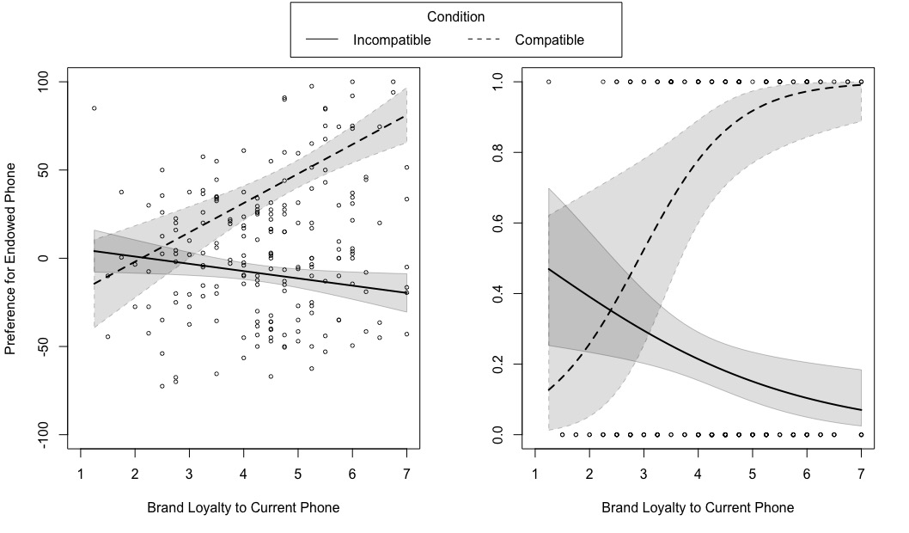
Figure 1. The effect of brand loyalty and compatibility condition on the reported preference for the endowed phone (left) and the incentivized choice (right, logit model fit). The grey region surrounding the regression lines represent the 95% confidence intervals.

Incentivized preference. In addition to reported smartphone preferences, we asked participants to respond to an incentivized choice by asking participants which smartphone they would like to win in a raffle. We ran a logistic multiple regression with incentivized choice (0 = non-endowed smartphone, 1 = smartphone) as the dependent variable. Compatibility condition (-1 = incompatible, 1 = compatible), brand loyalty (mean centered), and their interaction were included as predictors, R² = .47, (Nagelkerke, 1991). The analysis revealed that compatibility, b =1.63, SE = 0.26, p < .001, OR = 5.09, 95% CI [3.17, 9.19], significantly predicted choices, but brand loyalty did not b = 0.36, SE = 0.23, p = .110, OR = 1.44, 95% CI [0.96, 2.40]. However, supporting the preference strength hypothesis, these main effects were qualified by a significant interaction, b = 0.79, SE = 0.23, p < .001, OR = 2.21, 95% CI [1.47, 3.68].
We probed this interaction effect at +1 SD and -1 SD of brand loyalty. We found that for participants high in brand loyalty (+1SD) the effect of the compatibility condition, b = 2.65, SE = 0.47, p < .001, OR = 14.10, 95% CI [6.38, 42.43], was larger than for participants with low brand loyalty (-1SD), b = 0.61, SE = 0.30, p = .046, OR = 1.83, 95% CI [1.00, 3.37]. These results support the findings of the reported preference, showing that people high in brand loyalty are unlikely to opt for the endowed option unless it is in line with their previous preferences (Figure 1, Panel B).
Query order (SMDR). According to query theory, query order is related to the salience of the choice options. Thus, to test the effect of brand loyalty (mean centered) and compatibility (incompatible = -1, compatible = 1) on query order (SMDR), we ran a multiple regression analysis, F(3,198) = 15.99, p < .001, R² = .20. We found a significant main effect of compatibility, b = 0.39, SE = 0.07, p < .001, but no effect of brand loyalty on SMRD, b = -0.04, SE = 0.05, p = .440. However, these main effects were qualified by an interaction, b = 0.14, SE = 0.05, p = .012, as predicted by the preference strength hypothesis.
We probed this interaction effect at +1 SD and -1 SD of brand loyalty. We found that for participants high in brand loyalty (+1SD) the effect of the compatibility condition was significant, b = 0.57, SE = 0.09, p < .001. However, for participants who indicated low brand loyalty (-1SD), the compatibility condition had no effect on query order, b = 0.21, SE = 0.11, p = .061. This suggests that people who are high in brand loyalty will first think about their preferred phone, whereas for those who are low in brand loyalty the compatibility condition did not affect their memory retrieval order (Figure 2). In fact, for participants with low brand loyalty we find that the intercept is significantly different from zero in a positive direction, b = 0.33, SE = 0.11, p = .003, this indicates that participants with low brand loyalty were more likely to think of the endowed phone first regardless of their compatibility condition.
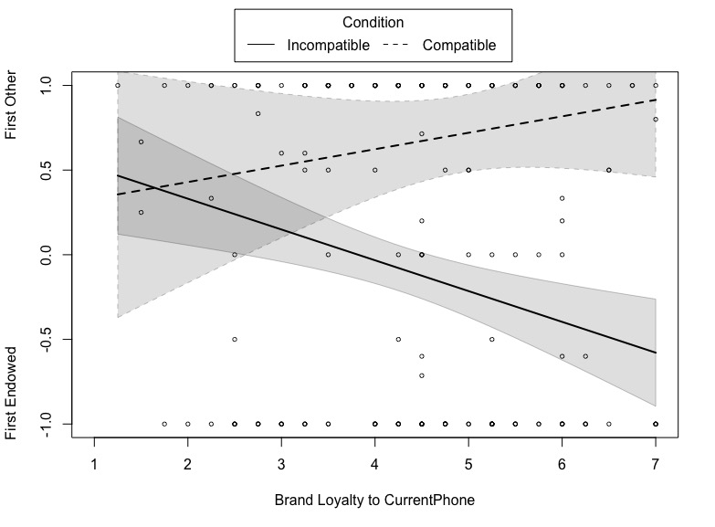
Figure 2. The effect of brand loyalty and compatibility condition on query order (SMRD). The grey region surrounding the regression lines represent the 95% confidence intervals.
Additional analyses.
Perceived ownership. One line of research on the endowment effect proposes that participants begin to feel a sense of ownership towards the endowed option which leads them to place higher value on the endowed object (Morewedge et al., 2009). We tested if brand loyalty (mean centered) and compatibility (-1 = incompatible, 1 = compatible) could explain feelings of perceived ownership using a multiple regression analysis, F(3, 198) = 32.49, p < .001, R² = .33. The results showed a similar pattern as for the above described smartphone preferences. There was a significant main effects of compatibility condition, b = 0.34, SE = 0.13, p = .010, but not of brand loyalty, b = 0.11, SE = 0.10, p = .278. This main effect was qualified by a significant interaction effect, b = 0.22, SE = 0.10, p = .033. The simple slopes analysis showed that for people high in brand loyalty (+1SD) there was a significant effect of compatibility, b = 0.62, SE = 0.16, p < .001. However, for participants low in brand loyalty (-1SD) compatibility was not significant, b = 0.06, SE = 0.21, p = .773. These findings show that perceived ownership, which should only explain the endowment effect, is also affected by previous preferences, specifically brand loyalty.
Discussion
To test our three hypotheses about the effects of previous preferences and endowment, we measured participants brand loyalty to their current smartphone and then briefly endowed them with one of three smartphones. Measuring both preferences for the endowed smartphone and an incentivized choice for receiving the endowed smartphone in a raffle, we find the interaction of compatibility and brand loyalty as predicted by the preference strength hypothesis. Although not surprising that being endowed with a phone in line with your previous preferences is the winning hand, we also find that for people in the incompatible condition endowment had an effect. In fact, participants who were endowed with an incompatible smartphone were more likely to choose the smartphone they were endowed with, if they were low in brand loyalty. Thus adding additional support for the preference strength hypothesis. Furthermore, this pattern of results was also reflected in our measure of the memory retrieval processes underlying the choice. Participants with strong previous preferences found the smartphone in line with their previous preferences to be most salient. While for participants with weak previous preferences, their attention was drawn to the endowed smartphone
Experiment 2: Soda Beverages
Traditionally, in endowment experiments participants are given a product to keep. Only later on in the experiment do they have the option to sell or switch the product. In our first experiment, we were unable to give participants the smartphones to keep due to financial restrictions. Thus, in the traditional sense of the word, they were not officially endowed with a smartphone. To address this potential limitation, in our second experiment we endowed participants with a soda beverage which they are able to keep after completion of the experiment or switch for another brand of soda.
We opted for soda beverages in order to test our hypotheses with products for which previous preferences may be high, but for which the choice is not as financially costly to consumers and therefore maybe subject more heuristic decision-making. We aimed for two compatible products that people can experience a strong preference for, but also which most people do not consider to be overly important to them. We opted for the soda brands Lipton Ice Tea and Coca Cola based on a pilot study (N = 78). The measures and analysis of the pilot study can be found in the online supplemental materials on the Open Science Framework (OSF).
Method
Participants. In exchange for course credit or €8 cash, we recruited 571 Tilburg University students to participate in our laboratory experiment. We removed two participants because the computer failed half-way through the experiment. Additionally, we excluded participants from the analyses who either said they would take the soda can for a friend rather than for themselves (n = 58) or who did not sketch the can (n = 25), indicating that they did not follow instructions. This resulted in a final sample of 486 (339 women, 146 men, 1 other, M_{age} = 20.56, SD_{age} = 2.58). To determine which effect size we could detect with this final sample, we conducted a sensitivity analysis with G*Power (Faul et al., 2009). Specifically, we measured the ability to detect an increase in explained variance in our regression model by including an additional predictor. With our final sample, we would be able to detect an effect size of f = 0.13 with a power of 80%.
Procedure and materials. The experiment was conducted using Qualtrics survey software. Participants first filled out a purchasing habits questionnaire, to estimate their soda beverage preferences and demographics (age, gender, nationality, study program). After a filler task (i.e., an unrelated study from the experimental batch), participants continued on to the main experiment. Participants were randomly assigned to either the Coke or Lipton endowment condition, and asked to carefully inspect and sketch the soda can they were endowed with. Next, participants completed an aspect listing task to measure their memory retrieval order and indicated their willingness to pay (WTP) and willingness to accept (WTA) for each of the soda beverages. Participants then self-coded their aspects, and were asked if they had previously participated in a similar study. Finally, before leaving the lab, participants were asked if they wanted to keep their soda can, or switch to a can of the other brand. Participants kept the soda that they choose. The experiment was conducted in English.
Brand habit. Following Verwijmeren, Karremans, Stroebe, and Wigboldus (2011), we asked participants how often they bought different soda brands: Coca Cola, Pepsi, Sprite, Lipton Ice Tea, and Fanta. Participants responded to the question “When you buy a soft drink, how often do you buy…?” on a six-point scale from 1 (never) to 6 (always). To divert from our true measures of interest (preference for Coke and Lipton), we also asked them about their preferences for candy bar brands, shampoo brands, and tooth paste brands.
Endowment condition. Participants were instructed to look under the computer desk and retrieve the box that was hidden there. Participants were then asked to remove the soda can that was in the box. This was either a can of Coke or a can of Lipton depending on the experimental condition. Participants were instructed to carefully inspect the can and sketch it in as much detail as possible, to ensure that participants actually handled and interacted with the can. Participants who did not sketch the can, were removed from analysis for not following instructions.
Aspect listing. As in Experiment 1, we employed the aspect listing methodology to measure their query order. We told participants that at the end of the experiment they would be able to keep the can they just sketched or that they could switch the other brand (Coke or Lipton respectively). Participants were instructed to list all the reasons that passed through their minds while considering whether to keep the can or switch to the other brand. After entering their first response in a text box, participants clicked the submit button to bring them to the aspect listing question on the next screen where they could list a second response. This process was repeated until participants indicated they did not have any more reasons to list (M =3.03, SD =0.74, Range [1, 6]). As in the previous experiment, responses were limited to 200 characters and participants were not trained in advance.
Self-coding of aspects. Participants coded the reasons they listed in the aspect listing task, as either in favor or against each soda brand (Johnson et al. 2007). Responses indicating that the aspect was “in favor of keeping the can of Lipton Ice Tea” and those “against switching to the can of Coca Cola” were grouped together, as in a dichotomous choice a reason against switching to Coke results in a reason for keeping the can of Lipton. Similarly, responses “in favor of keeping the can of Coca Cola” and “against switching to the can of Lipton Ice Tea” were grouped together.
Query order (SMRD). We measured query order (Johnson et al., 2007) in the same way as in Experiment 1. SMRD scores reflect participants’ tendency to list reasons in favor of choosing Lipton before reasons in favor of choosing Coke. It is defined as 2(MR_{Coke} – MR_{Lipton})/n.
Soda choice. When the participant completed the experiment, the participant contacted the research assistant via the intercom system, who then came to escort them out of the cubicle. The research assistant would then hold up a can of the other soda brand and tell participants that they could either keep the can they had sketched or switch to the other brand. The lab assistant made a note of which can the participant decided to keep. Participants who strongly insisted that they did not want either can (e.g., because they do not drink carbonated beverages) or who explicitly said they would take the can for a friend were removed from the analysis (n = 58).
Results
Analysis Strategy. For each of the dependent variables, we fit a (logistic) multiple regression model. We included the predictors endowment condition (-1 = Coke,1 = Lipton), Coke purchasing habits (mean centered), Lipton purchasing habits (mean centered), as well as the interaction of endowment ✕ Coke purchasing habits and the interaction of endowment ✕ Lipton purchasing habits. This regression model allowed for us to test the unique effects of purchasing habits in favor of one soda brand while controlling for the purchasing habits of the other brand. All model coefficients are reported in Tables 1 and 2.
Choice. Our logistic multiple regression model explained a significant amount of the variance in soda choices, where high scores indicate a choice for Lipton and low scores a choice for Coke, χ²(5) = 93.4, p < .001, R² = .36 (Nagelkerke, 1991). The analysis revealed significant main effects of both Coke and Lipton purchasing habits along with a significant main effect of endowment. This supports the previous preferences hypothesis. Neither of the interaction terms were statistically significant, thus ruling out our preference strength hypothesis. The finding suggests that people are more likely to choose the soda brand in line with their previous preferences. However, being endowed with that same brand gives the product an additional boost, although this did not differ for participants with strong or weak previous preferences.
Table 1
Summary of the Logistic Regression Model for Choice in Experiment 1 (N = 486)
 | b | SE | p | OR | CI95% OR
Intercept | 1.02 | 0.13 | .<.001*** | 2.76 | [2.15, 3.63]
Lipton Habits | 0.57 | 0.08 | <.001*** | 1.76 | [1.53, 2.06]
Coke Habits | -0.60 | 0.09 | <.001*** | 0.55 | [0.46, 0.64]
Endowment | 0.79 | 0.13 | <.001*** | 2.21 | [1.71, 2.90]
Lipton Habits ✕ Endowment | 0.09 | 0.08 | .356 | 1.07 | [0.93, 1.25]
Coke Habits ✕ Endowment | -0.02 | 0.09 | .809 | 0.98 | [0.82, 1.55]
Note: *p < .050, ** p < .010, *** p < .001, higher scores indicate a higher likelihood to make the choice in favor of Lipton.

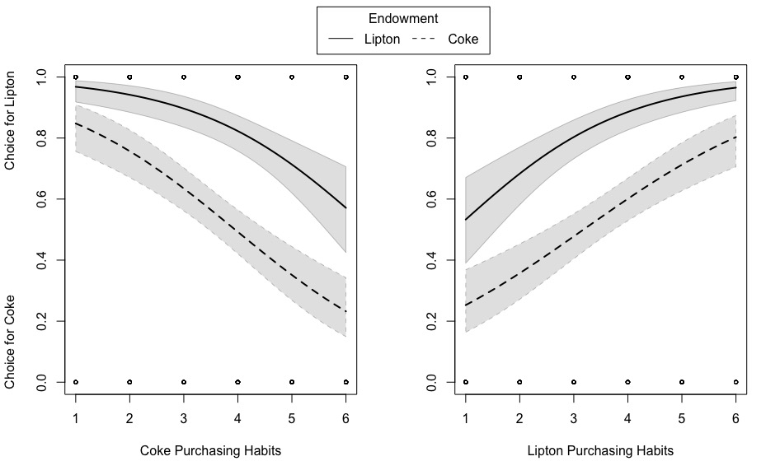
Figure 4. Predicted values for the modeled logistic regression of purchasing habits on soda choices in Experiment 2. The grey region surrounding the regression lines represent the 95% confidence intervals.

Additional analysis. To get a better picture of our results, we estimated the effect of endowment on soda choice while disregarding purchasing habits. We found that 82.51% of participants opted for Lipton when they were endowed with Lipton, but 55.16% of participants still opted for Lipton when they were endowed with Coke, χ²(1) = 30.86, p < .001. This indicates that there was generally a larger preference for Lipton, but that the endowment condition boosted that preference. In total, 61.24% of participants opted for the soda brand they were endowed with.
Query order (SMRD). To test the effect of endowment and purchasing habits on the order in which people retrieve information from memory, we ran a multiple linear regression analysis with participants’ SMRD scores as the outcome variable, F(5,480) = 33.26, p < .001, R² = .26 (Figure 5). The results revealed that both Coke and Lipton purchasing habits as well as the endowment condition predicted SMRD scores. Here we also found a significant interaction of Coke purchasing habits ✕ endowment. The interaction of Lipton purchasing habits ✕ endowment was not significant.
We probed the significant interaction at -1SD and +1SD of Coke purchasing habits. In line with the preferences strength hypothesis, we find that for participants with weak purchasing habits of Coke, b = 0.13, SE = 0.05, p = .012, there was a smaller effect of endowment than for participant with a high purchasing habit of Coke b = 0.30, SE = 0.5, p <.00. In other words, participants who had low purchasing habits for Coke thought about Coke first only slightly more if they were endowed with Coke instead of Lipton. However, participants who had a high preference for Coke, thought of Coke first to a much larger degree when they were endowed with Coke instead of Lipton.
Table 2
Summary of Multiple Regression Model for Query Order (SMRD)
 | b | SE | p
Intercept | 0.29 | 0.04 | <.001***
Lipton Habits | 0.18 | 0.02 | <.001***
Coke Habits | -0.21 | 0.02 | <.001***
Endowment | 0.22 | 0.04 | <.001***
Lipton Habits ✕ Endowment | -0.02 | 0.02 | .332
Coke Habits ✕ Endowment | 0.05 | 0.02 | .030*
Note: *p < .050, ** p < .010, *** p < .001
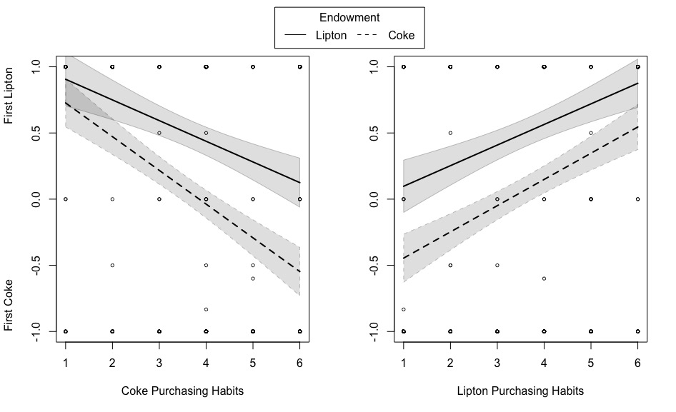Figure 5. Predicted values for the modeled multiple regression of purchasing habits and endowment on query order (SMRD). The grey region surrounding the regression lines represent the 95% confidence intervals.

Additional analysis. A closer look at participants’ SMRD scores, revealed that all but 21 participants had a score of -1 or 1. Therefore, we ran a sensitivity analysis by testing our effects using a dichotomous measure of query order. We ran a logistic regression analysis on query order (0 = all reasons for Coke first, 1 = all reasons for Lipton first), while excluding these 21 participants (N = 465). The analysis revealed a similar pattern as for the continuous measure of query order, χ²(5) = 88.1, p < .001, R² =.35. There were significant main effects of both Coke, b = -0.74, SE = 0.12, p < .001, OR = 0.48, 95% CI [0.38, 0.59], and Lipton purchasing habits, b = 0.59, SE = 0.11, p < .001, OR = 1.80, 95% CI [1.48, 2.24], and a significant main effect of endowment, b = 1.25, SE = 0.25, p < .001, OR = 3.48, 95% CI [2.16, 5.75]. However, none of the interaction effects were significant, ps < .250. Thus, showing the same pattern of results as for the choice of soda brand.
Discussion
We tested our three hypotheses regarding the effect of previous preferences, endowment, and their interaction using a choice between soda brands. After measuring participants soda purchasing habits, we endowed each participant with either a can of Coke or Lipton and measured which of the two sodas participants opted to take home with them. As in Experiment 1, we find that both previous preferences, that is, purchasing habits, and endowment play a role in choices. However, unlike Experiment 1, we do not find the interaction affect predicted by the preference strength hypothesis. Instead our results show support for both the previous preferences hypothesis. However, it is important to note that endowment did not play an insignificant role in soda choices. Similar to Experiment 1, it seems that to receive the winning hand is to be endowed with a product in line with your previous preferences. However, this effect does not differ for people with strong or weak previous preferences.
We also found that query order reflected participants’ choices. Participants were more likely to first think of the product they were endowed with, but also of products that they had a previous preference for. Although, there was a significant interaction effect of endowment and Coke purchasing habits, this interaction did not survive a sensitivity analysis. This suggests that the interaction was relatively unstable and that query order reflects the same pattern as the final soda choice, which is in line with the premises of query theory.
General Discussion
A choice situation can consist of many different decision-making cues. In our research, we examined how cues of endowment and previous preferences affect choices as a result of shifting the salience of a choice option during the decision-making processes. Using query theory (Johnson et al., 2007), we measured which decision cue was most salient for participants and found that memory retrieval order was consistent with choices. For both smartphones and soda brands, we find that previous preferences play an important role on choices and decision processing regardless of endowment. However, the nature of the effect of previous preferences differs. In our Experiment 1, we find that the preference strength hypothesis predicted preferences and incentivized choices for smartphones. In Experiment 2, we find support for the previous preferences hypothesis, suggesting that participants were more likely to opt for the beverage in line with their previous preferences above and beyond endowment. It appears that (strong) previous preferences cannot easily be overridden by endowing participants with a product.
Of course, we cannot discount the effect of endowment. While it may not be a strong enough cue to override (strong) previous preferences, it does factor significantly into the decision-making process. Rather than overriding previous preferences, the endowment effect is qualified by pre-existing preferences so that may become weaker, especially for consumers with strong previous preferences. As such, the endowment effect may be most effective for people who do not have strong pre-existing preferences for the alternative option in a choice set when endowment is introduced. For smartphones we find that for participants with weak previous preferences, compatibility condition does not affect preferences. For sodas, on the other hand, we find a main effect of endowment, showing that endowment acts as a boost to your previous preferences regardless of the strength of your previous preferences. Nonetheless, being endowed with the brand in line with your previous preferences seems to be the winning hand, both in terms of decision processing and the final choice.
Research on the endowment effect has repeatedly shown the strength and robustness of this effect (Morewedge & Giblin, 2015). We provide additional evidence that endowment is effective, especially when it is in line previous preferences. However, in some cases previous preferences can even override the endowment effect, showing that it is vital to take previous preferences into account when studying the endowment effect. After all, endowment does not occur in a vacuum. Decision makers enter into most choice contexts, including endowment, with their previous experiences and preferences in place. As these previous preferences are usually chronically accessible to people, leading to earlier memory retrieval during the decision-making process, they will shape the choice either boosting or attenuating the endowment effect.
Previous preferences: Brand loyalty vs. purchasing habits?
While we find ample support that previous preferences matter. However, our experiments show conflicting results about the nature of their effect. In our first experiment, we find support for the preference strength hypothesis, suggesting that strong previous preferences completely override the endowment effect. People with weak preferences are more likely to opt for the endowed option when endowed with an incompatible product compared to people with strong previous preferences. In our second experiment, we find support for the previous preferences hypothesis, suggesting that pervious preferences predict choices while working in tandem with the endowment effect (i.e., the endowment give these previous preferences a boost). Although, our data cannot directly speak to the causes of these differences, the differences in the experimental design and operationalizations of constructs may provide some valuable insight into what may affect the role of previous preferences on the endowment effect.
First, the products used in our two experiments differ substantially on a few dimensions, first and foremost in monetary value and frequency of purchase. Smartphones are significantly more expensive than soda beverages and are purchased less frequently in general. Most smartphone providers in the Netherlands require costumers to commit to a one- or two-year contract, leading most consumers to only update their smartphones in (bi-)yearly periods. Additionally, the high costs of smartphones make them a substantial and risky purchase, especially for students with no or low incomes who were the subject pool in Experiment1. Given these factors, the decision of which smartphone to purchase may be subject to a more deliberate decision-making process, leaving more room to take previous experiences into account or to being more hesitant at accepting and implementing product information obtained in a very short period of time (i.e., endowment).
If smartphones do elicit a more deliberative decision-making processes, there may also be more room to evaluate not only positive but also negative previous experiences with smartphone brands. In other words, low scores of self-reported brand loyalty may not only reflect a lack of brand loyalty towards a smartphone brand, but potentially also an obvious dislike for the brand. Previous research has shown that product trials, which are similar to endowment, can lead to a decrease in preference for the product (de Groot, Antonides, Read, & van Raaij, 2009). During the trial period consumers also have the opportunity to become familiar with the negative aspects of the product. As such, previous experiences may also lead to greater disliking of the product and therefore a negative evaluation of the product. This could lead consumers with weak preferences or dislike of the product to be more open to endowment as a cue in the decision-making process. Indeed, we find that people who scored low on brand loyalty were much more likely to choose the incompatible endowed option than those who scored high on brand loyalty.
Conversely, soda beverages may elicit less deliberate decision processing, as these purchases occur more frequently and a wrong decision is less costly to the consumer. We opted to measure previous preferences in the soda experiment using self-reported purchasing habits. Habits are behavioral tendencies that are repeated often and are not always reflected in people’s thoughts or intentions (Wood, Quinn, & Kashy, 2002). Additionally, habits are stable across different decision contexts and are driven by past performance. As such, previous preferences take the lead in making choices in favor of a can of soda. Additionally, this less reflective decision-making process may also explain why endowment continues to play a role in soda choices. Rather than overriding endowment, the effect of endowment is simply combined with that of previous preferences, leading to our findings in favor of the previous preferences hypothesis, while still finding an effect of endowment across different levels of purchasing habits.
In Experiment 1, we do not endow participants with a smartphone in the traditional sense of the word. Due to financial restrictions we could not give participants the smartphones to keep. An additional limitation in this experiment is that we could not measure real switching behavior. Instead, we attempted to measure real preference by including an incentivized choice with lottery system. However, one problem with lotteries is that most participants realize that they have a relatively small chance of winning. They may not truly believe that they will receive the item they chose. To address these problems, we provided participants with an endowed soda to keep and an incentivized, consequential switching choice in Experiment 2. All participants were aware from the time they were endowed with a soda can that they could take the can home with them. However, we cannot know for sure if participant took the soda for their own consumption. Some participants clearly indicated that they took the can for someone else and were dropped from the analysis. However, this exclusion criterium was based on self-report and therefore may not have captured all participants who took the soda for someone else. This would have impacted the importance of personal previous preferences as a cue in the decision-making process.
Directions for future research
A closer look at different measures of preference is called for. In the domain of brand loyalty, both attitudinal and behavioral measures are used (Jacoby & Chestnut, 1978). However, they may be capturing different decision-making processes, deliberate vs. habitual, and therefore lead to differences in decision outcomes. In our studies, we examined the underlying decision-making processes using query theory (Johnson et al., 2007), measuring the memory retrieval order during the decision-making process to determine which option was most salient. This method may be better at capturing more deliberate and reflective decision-making processes than habitual decision-making processes. In fact, simply asking participants who are in a more habitual and automatic decision-making mindset to list all of their thoughts may shift their decision-making processes all together. Therefore, it should also be investigated if a query theory approach to determining salience will yield the same results as a more unobtrusive measurement of decision processing, for example eye tracking methodology.
Another avenue for exploration is the types of cues introduced into a status quo. In our experiments we test the effects of endowment and previous preferences on choices and their underlying memory retrieval processes. However, other cues may also play an important role in consumer decision-making. For instance, strongly held attitudes and beliefs could play and important role, even when they go against both previous preferences and endowments. One example could be products with moral value cues, for example environmentally friendly or fair-trade products. If people hold strong beliefs about the topic of environmentalism or human rights, such cues may act as the most salient option, regardless of other decisional cues in the decision context. Identifying such cues and investigating their combined effect on decision-making, may not only help us to understand why people do (not) purchase environmentally or socially impactful products, but may also give us insights into how we can shift salience towards such cues, without impacting consumers freedom of choice.
Conclusion
Within the current state of affairs different decision cues exist. Which of these options acts as a salient reference point can shift decision-making processes as well as their outcomes. We find that previous preferences are not to be discounted, even when another strong cue of endowment is present. Overall, people are likely to stick with their previous preferences, especially if these previous preferences are strong. Nonetheless, endowment is still important. In fact, we can boost the preference for the brand in line with previous preferences if you also endow the consumer with it. As such, knowing and understanding the combined effect of decision cues can help us understand for whom altering the decision-making context, for example by endowing them with a good, will be most effective: The winning hand is the product in line with previous preferences and acts as an endowment. It cannot lose!
References
Anderson, M. C., Bjork, R. A., & Bjork, E. L. (1994). Remembering can cause forgetting - Retrieval dynamics in long-term-memory. Journal of Experimental Psychology - Learning Memory and Cognition, 20(5), 1063-1087. doi:10.1037/0278-7393.20.5.1063
Anderson, M. C., & Spellman, B. A. (1995). On the status of inhibitory mechanisms in cognition - Memory retrieval as a model case. Psychological Review, 102(1), 68-100. doi:10.1037/0033-295x.102.1.68
Bar-Hillel, M., & Neter, E. (1996). Why are people reluctant to exchange lottery tickets? Journal of Personality and Social Psychology, 70(1), 17-27.
Bhatia, S. (2017). Comparing theories of reference-dependent choice. Journal of Experimental Psychology: Learning, Memory, and Cognition, 43(9), 1490-1507. doi:10.1037/xlm0000384
Chaudhuri, A., & Holbrook, M. B. (2001). The Chain of Effects from Brand Trust and Brand Affect to Brand Performance: The Role of Brand Loyalty. Journal of Marketing, 65(2), 81-93.
de Groot, M. I., Antonides, G., Read, D., & van Raaij, F. W. (2009). The effect of direct experience on consumer product evaluation. Journal of Socio-Economics, 38(3), 509-5018. doi:10.1016/j.socec.2008.08.008
Dempster, F. N. (1995). Interference and inhibition in cognition: An historical perspective. In F. N. Dempster & C. J. Brainerd (Eds.), Interference and inhibition in cognition (pp. 3-26). San Diego, CA: Academic Press.
Dinner, I., Johnson, E. J., Goldstein, D. G., & Liu, K. (2011). Partitioning default effects: Why people choose not to choose. Journal of Experimental Psychology: Applied, 17(4), 332-341. doi:10.1037/a0026470
Ericsson, K. A., & Simon, H. Z. (1984). Protocol analysis: Verbal reports as data (Revised Edition ed.). Cambridge, MA: The MIT Press.
Faul, F., Erdfelder, E., Buchner, A., & Lang, A. G. (2009). Statistical power analyses using G*Power 3.1: Tests for correlation and regression analyses. Behavior Research Methods, 41, 1149-1160. doi:10.3758/BRM.41.4.1149
Jacoby, J., & Chestnut, R. W. (1978). Brand Loyalty: Measurement and Management. New York: NY.: Wiley & Sons.
Jacoby, J., & Kyner, D. B. (1973). Brand Loyalty vs. Repeat Purchasing Behavior. Journal of Marketing Research, 10(1), 1-9. doi:10.2307/3149402
Johnson, E. J., Haubl, G., & Keinan, A. (2007). Aspects of endowment: A query theory of value construction. Journal of Experimental Psychology-Learning Memory and Cognition, 33(3), 461-474. doi:10.1037/0278-7393.33.3.461
Kahneman, D., Knetsch, J. L., & Thaler, R. H. (1990). Experimental tests of the endowment effect and the coase theorem. Journal of Political Economy, 98(6), 1325-1348. doi:Doi 10.1086/261737
Krishnamurthi, L., & Raj, S. P. (1991). An empirical analysis of the relationship between brand loyalty and consumer price elasticity. Marketing Science, 10(2), 172-183.
Mellens, M., Dekimpe, M., & Steenkamp, J. E. B. M. (1996). A review of brand loyalty measures in marketing. Tijdschrift voor Economie en Management, 41(4), 507-533.
Morewedge, C. K., & Giblin, C. E. (2015). Explanations of the endowment effect: An integrative review. Trends in Cognitive Sciences, 19(6), 339-348. doi:10.1016/j.tics.2015.04.004
Morewedge, C. K., Shu, L. L., Gilbert, D. T., & Wilson, T. D. (2009). Bad riddance or good rubbish? Ownership and not loss aversion causes the endowment effect. Journal of Experimental Social Psychology, 45(4), 947-951. doi:https://doi.org/10.1016/j.jesp.2009.05.014
Moshinksy, A., & Bar-Hillel, M. (2010). Loss aversion and the status quo label bias. Social Cognition, 28(2), 191-204.
Nagelkerke, N. J. D. (1991). A note on a general definition of the coefficient of determination. Biometrika, 78(3), 691-692.
Oppenheimer, D. M., & Kelso, E. (2015). Information processing as a paradigm for decision-making. Annual Review of Psychology, 66, 277-294.
Peck, J., & Shu, S. B. (2009). The effect of mere touch on perceived ownership. Journal of Consumer Research, 36(3), 434-447.
Samuelson, W., & Zeckhauser, R. (1988). Status quo bias in decision-making. Journal of Risk and Uncertainty, 1, 7-59.
Spälti, A. K., Brandt, M. J., & Zeelenberg, M. (2017). Memory Retrieval Processes Help Explain the Incumbency Advantage. Judgment and Decision-making, 12(2), 173-182.
Strahilevitz, M. A., & Loewenstein, G. (1998). The effect of ownership history on valuation of objects. Journal of Consumer Research, 25, 276-289.
Tom, G. (2004). The endowment-institutional affinity affect. The Journal of Psychology, 138(2), 160-170. doi:10.3200/JRLP.138.2.160-170
Verwijmeren, T., Karremans, J. C., Stroebe, W., & Wigboldus, D. H. J. (2011). The workings and limits of subliminal advertising: The role of habits. Journal of Consumer Psychology, 21(2), 206-213. doi:http://dx.doi.org/10.1016/j.jcps.2010.11.004
Wood, W., Quinn, J. M., & Kashy, D. A. (2002). Habits in everyday life: Thought, emotion, and action. Journal of Peronsality and Social Psychology, 83(6), 1281-1297. doi:10.1037//0022-3514.83.6.1281

WTP: Participants indicated the maximum amount of money they would be willing to pay for the three smartphones. They could choose from a dropdown list from <€500 to €1000 in €25 increments. Unfortunately, we found a floor effect for this question, with 35% participants indicating that they would pay less than €500 for all three smartphone (iPhone = 39%; Samsung = 50%, HTC = 78%). Therefore, the differences in this measure per condition were not be analyzed.
If they owned more than one phone, they were informed to type the brand name of the phone that they used most often.
Traditionally, this measure has been used to calculate the query order between two choice options. However, in this experiment, participants could choose between three smartphones. Therefore, we opted to use a conservative measure of query order, whereby we do not code choices against the non-endowed option as a choice in favor of the endowed option (because there are two non-endowed options to choose from). This is a more conservative measure of query order, since it only captures queries clearly in favor of the endowed option.
https://osf.io/k5cq9/?view_only=14ef12422d8e4b6594167c05af0cb218
This experiment was completed by participants as part of a batch of three studies which had been combined to fill one hour, in order to award participants one credit hour for their participation. One of the other studies required a minimum sample size of 435 participants based on a power analysis. We scheduled the lab for one week at a time, repeating this procedure until we had reached a sample size of more than 435 participants.
We included self-devised hypothetical measures of WTP and WTA. These are reported in the online supplemental materials on OSF. However, we came to realize that our measures did not tap into the traditional definitions of WTP and WTA and are thus not comparable to traditional value paradigms of the endowment effect.
In order to ensure that participants would not drink the soda, we told participants that drinking was prohibited in the lab.

