Main Manuscript for

The role of conspiracy beliefs for COVID-19 health responses: A meta-analysis
Kinga Bierwiaczonek¹*, Aleksander B. Gundersen¹, & Jonas R. Kunst¹
¹ Department of Psychology, University of Oslo, Postboks 1094, Blindern, 0317 Oslo, Norway

* Corresponding author, email: k.m.bierwiaczonek@psykologi.uio.no

Funding:
J.R.K. and A.B.G were supported by an EEA Grant 2014-2021 (Nr. 2019/35/J/HS6/03498) in the IdeaLab call operated by the National Science Centre (NCN). The funding source was not involved in study design, in the collection, analysis and interpretation of data, in the writing of the report, or in the decision to submit the article for publication.

Note: This is a preprint of a manuscript that is currently in press in Current Opinion in Psychology.

Abstract
While conspiracy theories about COVID-19 are proliferating, their impact on health-related responses during the present pandemic is not yet fully understood. We meta-analyzed correlational and longitudinal evidence from 53 studies (N = 78,625) conducted in 2020 and 2021. Conspiracy beliefs were weakly associated with more reluctance toward prevention measures both cross-sectionally and over time. They explained lower vaccination and social distancing responses but were unrelated to mask wearing and hygiene responses. Conspiracy beliefs showed an increasing association with prevention responses as the pandemic progressed and explained support for alternative treatments lacking scientific bases (e.g., chloroquine treatment, complementary medicine). Despite small and heterogenous effects, at a large scale, conspiracy beliefs are a non-negligeable threat to public health.

Keywords: Conspiracy beliefs, COVID-19 prevention, meta-analysis

1. Introduction

The spread of the coronavirus has been accompanied by a massive spread of conspiracy theories. Although the study of conspiracy theories has a long-standing and interdisciplinary tradition [1-3], uncertainty about their role in people’s health-related responses during the present pandemic remains. Whereas some studies suggest that conspiracy beliefs may undermine the global efforts to contain the virus by reducing people’s adherence to prevention guidelines such as social distancing [4,5,6], hygiene [5,6], and vaccination [7,8], other studies fail to replicate these effects [9] or point toward more complex links [10]. Thus, an accurate estimate of the overall effect of conspiracy beliefs on health responses across cultures and contexts, including the role of potential moderators, is yet to be established.
Given the pervasive and global impact of the pandemic, understanding the conditions under which conspiracy theories may undermine preventive health responses and sometimes even lead people to pursue risky alternative treatment is an urgent issue. Here, we provide the first meta-analytic test of the effect of conspiracy beliefs on people’s health-related responses during the pandemic. We focus on attitudes toward, and self-reported compliance with, COVID-19 prevention measures (e.g., social distancing, mask-wearing, hygiene, vaccination), as well as attitudes toward, and self-reported adherence to, alternative treatments for COVID-19 (e.g., chloroquine, garlic, vitamin C). We meta-analyze data from 53 published and unpublished manuscripts from the first year of the pandemic (March 2020 through May 2021), including 310 effects from 93 independent samples in 23 countries (N = 78,625). In doing so, we aim to address several questions of broad significance that have produced mixed research results or remain unaddressed to date. Are some conspiracy beliefs more harmful than others? Do they influence certain health-related attitudes and behaviors more than others? Do conspiracy beliefs exert the same effect throughout the pandemic or does their association with health responses change as the pandemic progresses? Are conspiracy beliefs influential especially in specific countries, or do they have a high potential to harm precisely because their effects are relatively context independent?

2. Results

Addressing the mixed results of single studies [4,5,8,9], our first goal was to estimate the average effect of conspiracy beliefs on prevention responses across the available research. Results from a multi-level meta-analysis [11] showed that believers in conspiracy theories overall are slightly more reluctant toward prevention than non-believers (r = -.13, 95% CI = [-.17, -.09]). This small negative effect was replicated in a cross-lagged panel model based on a smaller selection of studies that employed repeated measurements (r = -.09, 95% CI = [-.11, -.07], Figure 1A). People who held stronger conspiracy beliefs at one point in the pandemic tended to be more reluctant toward COVID-19 prevention measures at later points, and vice versa. Yet, these effects were extremely heterogenous, suggesting that the association between conspiracy beliefs and health behaviors may play out differently under different conditions.
The next crucial question was whether some conspiracy beliefs are more harmful than others. Taken together, beliefs that specifically concerned COVID-19 (combined effect: r = -.15, 95% CI = [-.19, -.11]) seemed only slightly more predictive of health responses than a general tendency to believe in conspiracies (r = -.12, 95% CI = [-.21, -.04]; Figure 1B); however, when we compared them in a meta-regression controlling for other moderators, this difference turned out to be significant (B = .12, 95% CI = [.07, .18], Table S1 in supplementary materials). Among the specific COVID-19 conspiracy beliefs, believing that the coronavirus is a man-made bioweapon stood out: its effect on prevention was close to zero and non-significant (r = .03, 95% CI = [-.09, .03]), whereas the effects of other beliefs (e.g., big pharma conspiracy, political conspiracy, hoax) were negative and significantly stronger (combined effect: r = -.20, 95% CI = [-.25, -.15]). Of all the conspiracy beliefs tested, the bioweapon theory is the only one that clearly implies that COVID-19 is extremely dangerous, explaining why those who believe in it do not show much reluctance toward prevention [5,9].
Next, we tested whether conspiracy beliefs would predict some types of prevention responses better than others (Figure 1C). Indeed, the effects were the strongest for attitudes toward vaccination and intentions to get vaccinated (e.g., willingness to vaccinate oneself or one’s family; r = -.31, 95% CI = [-.38, -.23]). Of note, all studies meta-analyzed here were conducted before COVID-19 vaccines were widely available. Hence, this effect may not reflect actual vaccination behaviors. Conspiracy beliefs were also negatively associated with attitudes and self-reported behaviors related to social distancing (r = -.10, 95% CI = [-.14, -.06]), whereas the effects were non-significant for mask wearing (r = -.02, 95% CI = [-.14, .09]) and hygiene measures such as frequent hand washing (r = -.02, 95% CI = [-.04, .07]). Because most people engage in measures such as hand washing regardless of the pandemic, such measures may not show association with conspiracy theories. Yet, it is also possible that supporters of conspiracy theories are the most reluctant toward the COVID-19 prevention measures associated with high perceived costs such as loneliness in the case of social distancing, or potential side effects in the case of vaccines [cf. 13].
Critically, our results further showed that the stronger one’s conspiracy beliefs are, the more positive one tends to be toward alternative treatments that lack a scientific basis (e.g., chloroquine, vitamin C, complementary medicine; r = .42, 95% CI = [.22, .59]). However, this effect was weaker when it referred to self-reported behavior (r = .23, 95% CI = [.06, .39]) than when it referred to attitudes toward such treatments (r = .52, 95% CI = [.25, .71]). Hence, conspiracy beliefs seem to translate more strongly into favorable attitudes toward alternative treatments than into behavior.
The time of data collection (coded as the number of days after the WHO proclaimed a world pandemic) significantly predicted the strength of the observed effects (B = -.23, 95% CI = [-.43, -.01], Figure 1D). The later into the pandemic, the stronger became the observed negative association between conspiracy beliefs and prevention responses. This finding may indicate that later into the pandemic, such beliefs became more typical of people who were reluctant toward prevention; either because those who were initially reluctant for other reasons than conspiracy beliefs (e.g., safety, effectiveness) started supporting prevention later, or because those who were reluctant started adopting conspiracy beliefs to justify their own reluctancy.

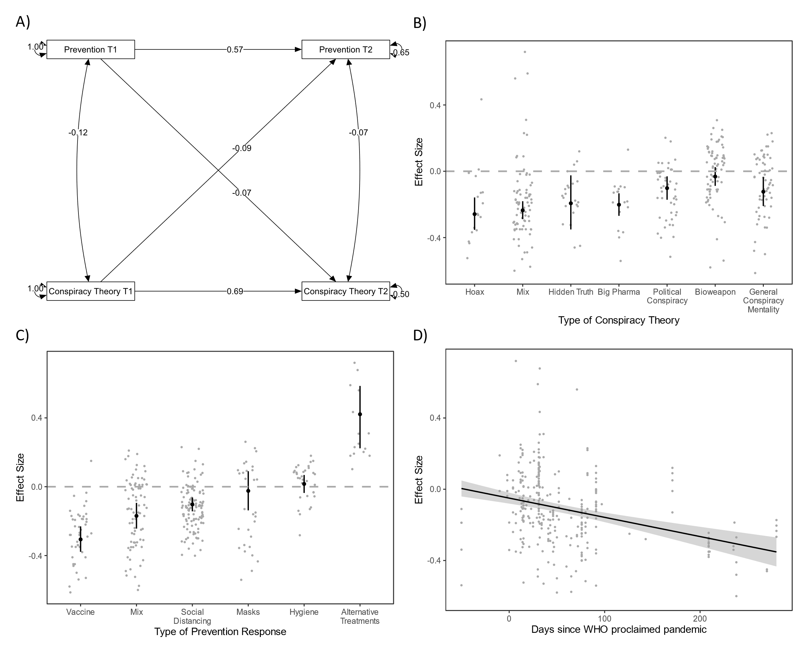

Figure 1. Effects of Conspiracy Beliefs on Health-Related Responses Over Time (A), by Type of Conspiracy Theory (B) and Type of Response (C), and Over the Time Since the WHO Proclaimed the Pandemic (D).

Note. Mix refers to measures that combined different types of conspiracy theories (B) or prevention responses (C) into one scale. Point estimates represent mean effect r, whereas error bars and ribbon represent 95% confidence intervals. The model presented in Figure 1A is based on effects from studies that included between two and five measurements. Effects from studies with more than two waves were pooled prior to analysis, hence only two timepoints are presented.
A final question of broad significance was whether the effects of conspiracy beliefs are relatively context independent or whether they emerge in some countries more than others. Because only 5% of the total variability of effects was attributable to the country level, the country contexts seemed unlikely to play a major role. Still, we tested for the influence of seven potential country-level moderators: inequality (the Gini index), the quality of democracy, freedom of press, access to education at a primary and higher level, citizens’ trust in institutions, as well as the stringency of the government response to the pandemic. None of the indicators significantly moderated the effects. Whereas it is possible that macro-level factors influence a population’s average endorsement of conspiracy theories [14,15], they may not determine whether such beliefs translate into prevention responses. Although the absence of moderation in itself is not enough to rule it out, it may suggest that conspiracy beliefs, once disseminated in a population, may negatively influence prevention irrespective of factors that would otherwise make societies resilient to misinformation.

3. Discussion

In sum, our meta-analysis shows that conspiracy beliefs predict people’s reluctance toward COVID-19 prevention measures, both cross-sectionally and over time. Even though the effects tend to be small, it is the unprecedented dimension of this pandemic that makes them dangerous; at such a large scale, any reluctance toward prevention measures poses a non-negligeable threat to public health and undermines global efforts to contain the virus. It should be noted that effects were highly heterogenous, which may reflect the dynamic nature of the pandemic and the shifting meaning of prevention measures (e.g., initial controversies around the efficacy of masks versus later mask mandates). Crucially, the negative effects of conspiracy beliefs are the strongest for vaccination and social distancing – the measures that in combination are highly effective in reducing the spread of the virus [16], and that rely heavily on the compliance of all. In addition to reducing adherence to prevention measures, conspiracy beliefs may harm people by making them pursue alternative treatments that are ineffective at best. Finally, the negative association between conspiracy beliefs and prevention responses seems to get stronger as the pandemic progresses. While this finding may seem alarming at a first glance, it does not necessarily imply that conspiracy beliefs became more powerful over time. Rather, it suggests that at later stages of the pandemic, conspiracy beliefs might have become a better factor distinguishing people who engaged in preventive behavior from those who did not.

4. Materials and Methods

The literature search for this meta-analysis was completed on May 23, 2021. To ensure high reliability, data from relevant studies were extracted independently by two trained coders. The analyses were conducted using the following approaches: multi-level meta-analysis, robust variance estimation, meta-analytical structural equations. The detailed description of methods and results, complete references of the included studies, as well as the full datasets, are available in the Supplementary Material via OSF: https://osf.io/ajym8/?view_only=b5ec322e8bde47eeaa4379f86557ca37.

Acknowledgments

We would like to thank all authors of primary studies that shared their data with us.

References

1. Bale JM: Political paranoia v. political realism: on distinguishing between bogus conspiracy theories and genuine conspiratorial politics. Patterns of Prejudice 2007, 41:45-60.
2. Pipes D: Conspiracy: How the paranoid style flourishes and where it comes from. New York: Simon & Schusters; 1997.
3. van Prooijen JW, Douglas KM: Belief in conspiracy theories: Basic principles of an emerging research domain. European Journal of Social Psychology 2018, 48:897-908.
*4. Bierwiaczonek K, Kunst JR, Pich O: Belief in COVID-19 Conspiracy Theories Reduces Social Distancing over Time. Applied Psychology Health and Well Being 2020, 12:1270-1285.

In a longitudinal study with five waves, the authors showed that conspiracy beliefs that COVID-19 is human made reduced people's adherence to social distancing despite the lack of a logical link between this specific belief and prevention measure. This finding suggests that conspiracy beliefs may have undesired outcomes regardless of their content.

*5. Imhoff R, Lamberty P: A Bioweapon or a Hoax? The Link Between Distinct Conspiracy Beliefs About the Coronavirus Disease (COVID-19) Outbreak and Pandemic Behavior. Social Psychological & Personality Science 2020, 11:1110-1118.

In one of the earliest published reports on the role of conspiracy beliefs during the pandemic, the authors showed in two cross-sectional studies that the outcomes of conspiracy beliefs depend on their content: beliefs that COVID-19 is a hoax were associated with less social distancing, whereas beliefs that the virus is human-made were not.

*6. Pummerer L, Bohm R, Lilleholt L, Winter K, Zettler I, Sassenberg K: Conspiracy Theories and Their Societal Effects During the COVID-19 Pandemic. Social Psychological & Personality Science 2021.

Using a variety of methods, including experimental and longitudinal designs, the authors showed that COVID-19 conspiracy beliefs decreased institutional trust, support of governmental regulations, as well as decreased adherence to social distancing.

7. Bertin P, Nera K, Delouvee S: Conspiracy Beliefs, Rejection of Vaccination, and Support for hydroxychloroquine: A Conceptual Replication-Extension in the COVID-19 Pandemic Context. Frontiers in Psychology 2020, 11:565128.
8. Freeman D, Loe BS, Chadwick A, Vaccari C, Waite F, Rosebrock L, Jenner L, Petit A, Lewandowsky S, Vanderslott S, et al.: COVID-19 vaccine hesitancy in the UK: the Oxford coronavirus explanations, attitudes, and narratives survey (Oceans) II. Psychological Medicine 2020:1-15.
9. Alper S, Bayrak F, Yilmaz O: Psychological correlates of COVID-19 conspiracy beliefs and preventive measures: Evidence from Turkey. Current Psychology 2020, doi:10.1007/s12144-020-00903-01-10.
*10. Chan H-W, Chiu CP-Y, Zuo S, Wang X, Liu L, Hong Y-y: Not-so-straightforward links between believing in COVID-19-related conspiracy theories and engaging in disease-preventive behaviours. Humanities and Social Sciences Communications 2021, 8:1-10.

In this large study, believing in risk-acceptance conspiracy theories (e.g., COVID-19 is a bioweapon) was linked to more preventive behaviours, while believing in risk-rejection conspiracy theories (e.g., COVID-19 is like influenza) was associated with fewer preventive behaviours.

11. Van den Noortgate W, López-López JA, Marín-Martínez F, Sánchez-Meca J: Meta-analysis of multiple outcomes: a multilevel approach. Behavioral Research Methods 2015, 47:1274-1294.
12. Hamaker EL, Kuiper RM, & Grasman RPPP: A critique of the cross-lagged panel model. Psychological Methods, 20.1: 102-116.
13. Jolley D, Douglas KM: The Effects of Anti-Vaccine Conspiracy Theories on Vaccination Intentions. PLOS ONE 2014, 9:e89177.
*14. Smallpage SM, Drochon H, Uscinski JE, Klofstad C: Who are the Conspiracy Theorists?: Demographics and conspiracy theories. In Routledge handbook of conspiracy theories. Edited by Butter MK, Peter: Routledge; 2020:263-277.

This chapter gives an overview of factors crucial to conspiracy beliefs, including cultural context conditions, demographic characteristics and group memberships. The authors consider cultural contexts dictating the content of conspiracy beliefs as a major difficulty in studying such beliefs cross-culturally.

*15. Salvador Casara BG, Suitner C, Jetten J: The impact of economic inequality on conspiracy beliefs. Journal of Experimental Social Psychology 2022, 98:104245.

In three studies, this paper cross-culturally and experimentally demonstrates the mutual links between economic inequality and conspiracy beliefs. The authors argue that economic inequality can cause conspiratorial thinking, which in turn can motivate collective action against economic inequality.

16. Huang B, Wang J, Cai J, Yao S, Chan PKS, Tam TH-w, Hong Y-Y, Ruktanonchai CW, Carioli A, Floyd JR, et al.: Integrated vaccination and physical distancing interventions to prevent future COVID-19 waves in Chinese cities. Nature Human Behavior 2021, 5:695-705.

This model does not include a random intercept. Although random intercept cross-lagged panel models [12] are generally preferable in primary studies, to the best of our knowledge such models have not yet been applied to meta-analytical data. Moreover, it is unclear whether a random intercept is necessary here, provided that the model is fitted on a matrix of pooled effects based on a random effects meta-analysis; that is, the variance of effects within and between studies is already taken into account.

