‘Intentional binding’ without intentional action
Keisuke Suzuki^{1,2}, Peter Lush^{1,2}, Anil K. Seth^{1,2}, Warrick Roseboom^{1,2}

¹ Department of Informatics, University of Sussex, Brighton BN1 9QJ, United Kingdom
² Sackler Centre for Consciousness Science, University of Sussex, Brighton BN1 9QJ, United Kingdom
Corresponding Author: K.Suzuki@sussex.ac.uk

Number of pages: 27
Number of figures: 5
Word Count: Abstract: 148, Introduction: 415, Methods: 1769, Results: 2008, Interim Introductions: 662, Discussion: 638, Acknowledgements: 59; A sum of Introduction, Interim Introductions, Discussion, and Acknowledgements: 1774.
Conflict of interests: The authors declare no competing financial interests

Abstract
The experience of authorship over one’s actions and their consequences - sense of agency - is a fundamental aspect of conscious experience. In recent years, it has become common to use intentional binding as an implicit measure of the sense of agency. However, it remains contentious whether binding effects indicate the role of intention-related information in perception or merely represent a strong case of multisensory causal binding. Here, we use a novel virtual reality setup to demonstrate identical magnitude binding effects both in the presence and complete absence of intentional action, when perceptual stimuli are matched for temporal and spatial information. Our results demonstrate that intentional binding-like effects are most simply accounted for by multisensory causal binding, without necessarily being related to intention or agency. Future studies which relate binding effects to agency must provide evidence for effects beyond that expected for multisensory causal binding by itself.

Keywords: Intentional Binding, Sense of Agency, Multisensory Integration, Virtual Reality, Augmented Reality

Introduction
The sense of agency is the feeling of authorship over one’s intentional actions and their external consequences (Haggard, 2017). Intentional binding refers to the perceived compression of the time interval between an intentional action (commonly a button press) and its outcome (commonly a brief auditory tone). This effect is often employed in empirical investigations of the sense of agency as an implicit measure, because while it appears to be sensitive to agency, it requires no explicit reflection upon agency (Moore & Obhi, 2012). Binding can be measured by various methods, including timing individual action and outcome events (Haggard, Clark, & Kalogeras, 2002), delay judgements (Kawabe, Roseboom, & Nishida, 2013) or direct estimation of intervals (Engbert, Wohlschläger, Thomas, & Haggard, 2007).

Differences in the magnitude of binding are often considered to reflect differences in the sense of agency (e.g. Caspar, Christensen, Cleeremans, & Haggard, 2016; Khalighinejad, Di Costa, & Haggard, 2016; Lush, Parkinson, & Dienes, 2016) but this relationship is not straightforward. It has been demonstrated that causal relationships influence binding to the degree that the effect can occur in the absence of intentional action, providing a causal relationship between the two events is believed to exist (Buehner, 2012, 2015; Buehner & Humphreys, 2009; Moore, Lagnado, Deal, & Haggard, 2009). Failing to control for the influence of causality on binding is likely to lead to inaccurate interpretations of results. For example, (Haggard et al., 2002) report differences in binding following either an intentional button press or movement triggered involuntarily. However, because the tone was not caused by the movement in the involuntary condition, differences in the magnitude of binding are likely to reflect beliefs about causality rather than intentions (Buehner, 2015; Desantis, Hughes, & Waszak, 2012). While binding can occur in the absence of intentions, intentional binding is generally stronger than that arising from the observation of external events believed to be causally related (Buehner, 2012, 2015), or from passive actions (Lush et al., 2017). It is currently an open question whether causal binding can be equal in magnitude to intentional binding as, to our knowledge, no statistical evidence has been published to test such a claim.

Here, we investigate whether equal magnitude temporal binding effects can be found with and without intentional action using an interval estimation task in a realistic virtual reality setup. Using virtual reality allows us to provide identical visual and tactile feedback for intentional and merely observed actions, matching the spatio-temporal properties of external sensory information between intentional and non-intentional presentations.

Methods

Participants
Fifty-one participants completed Experiment 1 (mean age = 24.14, SD = 5.21; 30 females, 5 left-handed). 20 participants completed Experiment 2 (mean age = 26.65, SD = 5.96; 12 females, 2 left-handed)). 30 participants completed Experiment 3 (mean age = 21.17, SD = 3.07; 23 females, 1 left-handed. Three participants were excluded from Experiment 1 as their responses did not increase proportionally to the presented temporal interval. Participants provided informed consent before taking part and received £5 or course credits as compensation for their time. The experiment was approved by the University of Sussex ethics committee.
Apparatus and Setup
In Experiment 1 and Experiment 2, we used a head mounted display (HMD) (Oculus Rift CV1, Oculus VR, Irvine, CA, USA) with an optical motion tracker (Leap Motion, LEAP MOTION, INC., San Francisco, CA, USA) attached to the front of the HMD. Sounds was presented through the headphones built into the HMD. To provide tactile stimulation, a vibrating motor (DC-3V, 10 x 3mm) was attached to the participant’s index finger. Participants were seated in front of a desk, situated so that they could comfortably rest their hands upon it. The desktop was transparent acrylic to enhance tracking performance of the optical motion tracker.

In Experiment 3, in addition to the above setup, we added a stereo camera (OVRVision, Shinobiya.com Co.,Ltd, Osaka, Japan) positioned immediately above the motion tracking sensor on the HMD. The desk and part of the background was covered with a green sheet. The image from the stereo camera was processed in chroma-key so that only the hand image was projected in the virtual environment. Participants could still interact with the virtual button through use of the tracking information from the optical motion tracker. The experiment setup was developed in Unity (Unity Technologies, San Francisco, CA, USA).

Within the HMD, participants were able to look around the 3D virtual space with the virtual desk located at approximately the same location as the physical desk. On the virtual desk, there was a red button (a round shape 2cm in radius and 2cm in height; with a button stroke of 1cm), which could be interacted with by the virtual hand. When pressed, the red button flashed white for 50msec and triggered the vibrating motor to vibrate for 50 msec, providing tactile feedback. White dots were drawn alongside the red button (9cm away from the button) on the desk, indicating the initial position of the hand during the experiment (See also Procedure). A spherical screen in the background projected a panoramic image of the experiment room, so that participants would feel as if they were physically located in the room. In Experiments 1 and 2 where virtual hands were presented, participants’ hands were tracked by the optical sensor and the hand movements replicated in the virtual hands in real time. We prepared male and female looking hands, each with 3 different possible skin tones (lighter, middle, and darker tones). The experimenter chose the hand model matching as closely as possible the participants’ real hand.

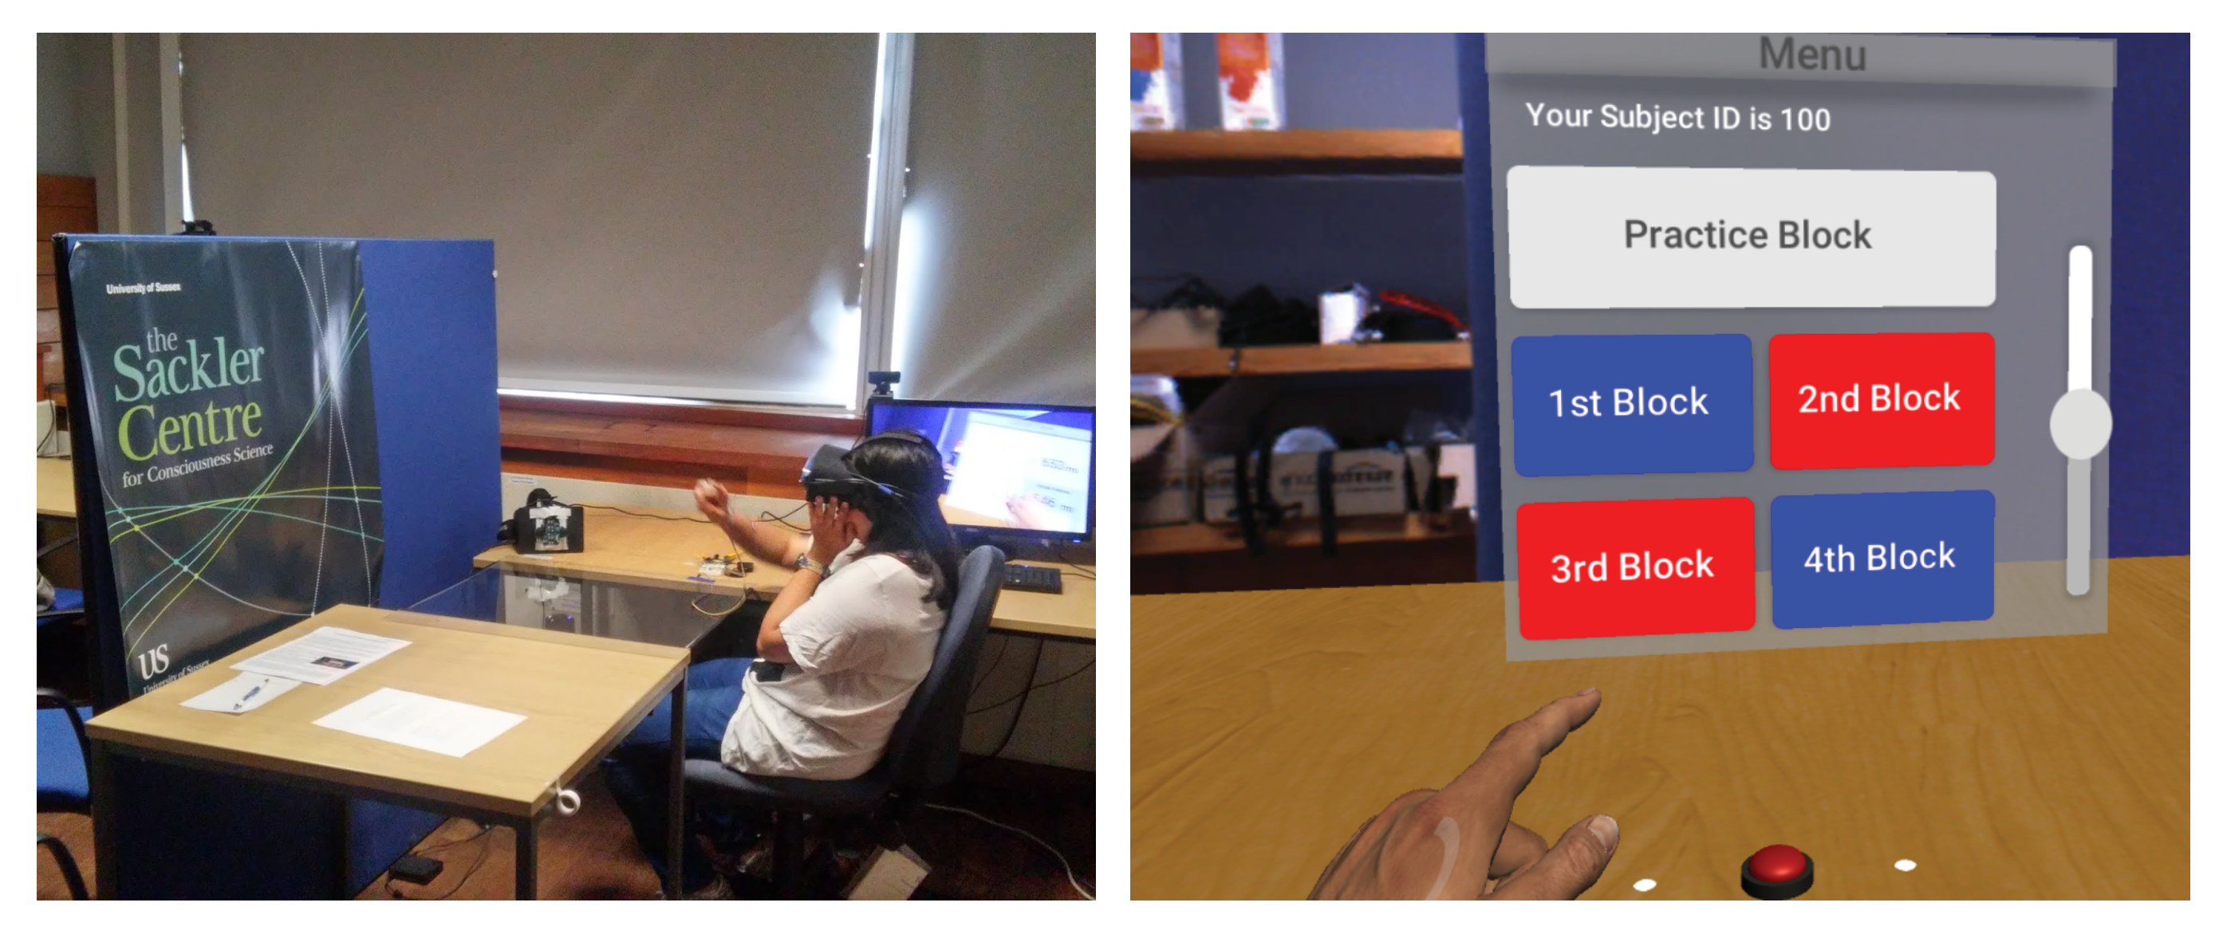 Figure 1. Experimental apparatus and participants’ view during the experiments. Left: External view of experiment setup. Right: Internal view with virtual hand, button, and response panel.

Procedure

Experiment 1
Participants wore the HMD and the vibrating motor was attached to the index finger of their dominant hand. The entire experiment, including task instructions and response screens, was completed within the virtual reality environment. The experiment consisted of three sessions: training, practice, and main session.

At the beginning of the experiment, all participants completed a training session in which they were familiarised to the interval estimation task. Participants heard two tones (880Hz, 50ms) in succession through the headphones in the HMD. The interval between the tones was pseudo-randomly chosen from three levels (200, 400, and 800msec). These three base intervals were identical to the ones used in the main experiments. To avoid participants using the training feedback (see below) to learn the specific three levels of interval that would be used in the main experiments, the interval in each trial was adjusted by a random jitter between -100 to +100msec. 500ms after the second tone denoted the end of the interval, a floating panel appeared in the HMD to prompt participants to report the estimated intervals using 3-digit numbers (Figure 2). They used their dominant hand to press numeric keys to enter the numbers. Immediately following entry of the third digit, the physically presented interval was shown on the panel to provide training feedback. Participants completed 18 trials in the training session.

After the training session, the participants moved to a practice session which was identical to Active block in the main session. Participants were instructed to press the red button on the virtual desk using the index finger of their dominant hand. They were also instructed to return their hand back the trial starting point (a white dot on the desk; left or right according to their dominant hand) following each response (Figure 1). A tone followed the button press after an interval (200, 400, or 800msec, pseudo-randomly selected). In this session, participants’ hand movements were recorded. Participants were instructed that it was crucial that they wait for a couple of seconds from the start of each trial before initiating their action in order to ensure temporal separation between trials. 500ms after the button was pressed, the floating number panel appeared, and they were prompted to enter their estimate of interval duration (no feedback regarding the actual duration was given during experimental trials). Data in the practice session were not included in the analysis. Participants completed 10 trials in the practice session.

The main experiment consisted of 2 sets of trials for each of 3 different conditions: Active (A), No Hand (N), and Fake (F). The order of the 3 conditions was randomised and counterbalanced across participants (e.g. AFNNFA for Participant 1, NFAAFN for Participant 2). In Active blocks, participants performed the same task as during the practice session. In No Hand and Fake blocks, participants were instructed not to move their hand. Instead, participants either observed the red button be depressed on its own (No Hand condition) or watched the virtual hand move and press the button (Fake condition). The hand movements in Fake trials were randomly selected from recordings of the participants’ own hand movements during the practice sessions. The No Hand and Fake conditions can be understood as different versions of a ‘passive’ condition in which the button press happens without intentional action. After a button press (either physically caused by participants in Active trials or automatically triggered in No Hand or Fake trials), participants reported button press-tone intervals as in the practice trials. After every 20 trials, there was a 10 second break. Participants completed 51 trials for each block of trials (17 trials per interval). The experiment took about 1 hour in total to complete, including instruction and debriefing.

Experiment 2
The procedure of Experiment 2 was identical to Experiment 1 but there was no interval judgement task and no No Hand condition (i.e., only Active and Fake conditions). In a given block of trials, participants were prompted to answer one of two distinct questions about agency and causality following each trial. The first question related to agency or control over the tone: “How much did you feel your action caused the tone to occur?”. The second question related to apparent causality more generally: “To what degree did the moving hand cause the tone to occur?”. These questions were answered by selecting 1-5 on a Likert scale, using a slider on a floating panel (Figure 2). Participants were carefully instructed in the precise meaning of these question (i.e. the former means YOU caused the tone to occur, and the latter means the HAND caused the tone to occur, regardless of the hand’s apparent connection to you).
As we did not use the interval judgement task, the training session regarding reporting the intervals was skipped. After completing the practice session regarding pressing the virtual button (as described above), participants started the two Active and two Fake blocks of trials, the order of which was counterbalanced across participants (i.e. ‘AFFA’ for odd numbered participants, ‘FAAF’ for even numbered participants). The floating panel on which the questions were presented appeared after participants pressed the button (Active trials) or after the virtual hand had pressed the button (Fake trials). One of the two questions (agency or causality) was presented in each block. The order of the questions was also counterbalanced across participants.
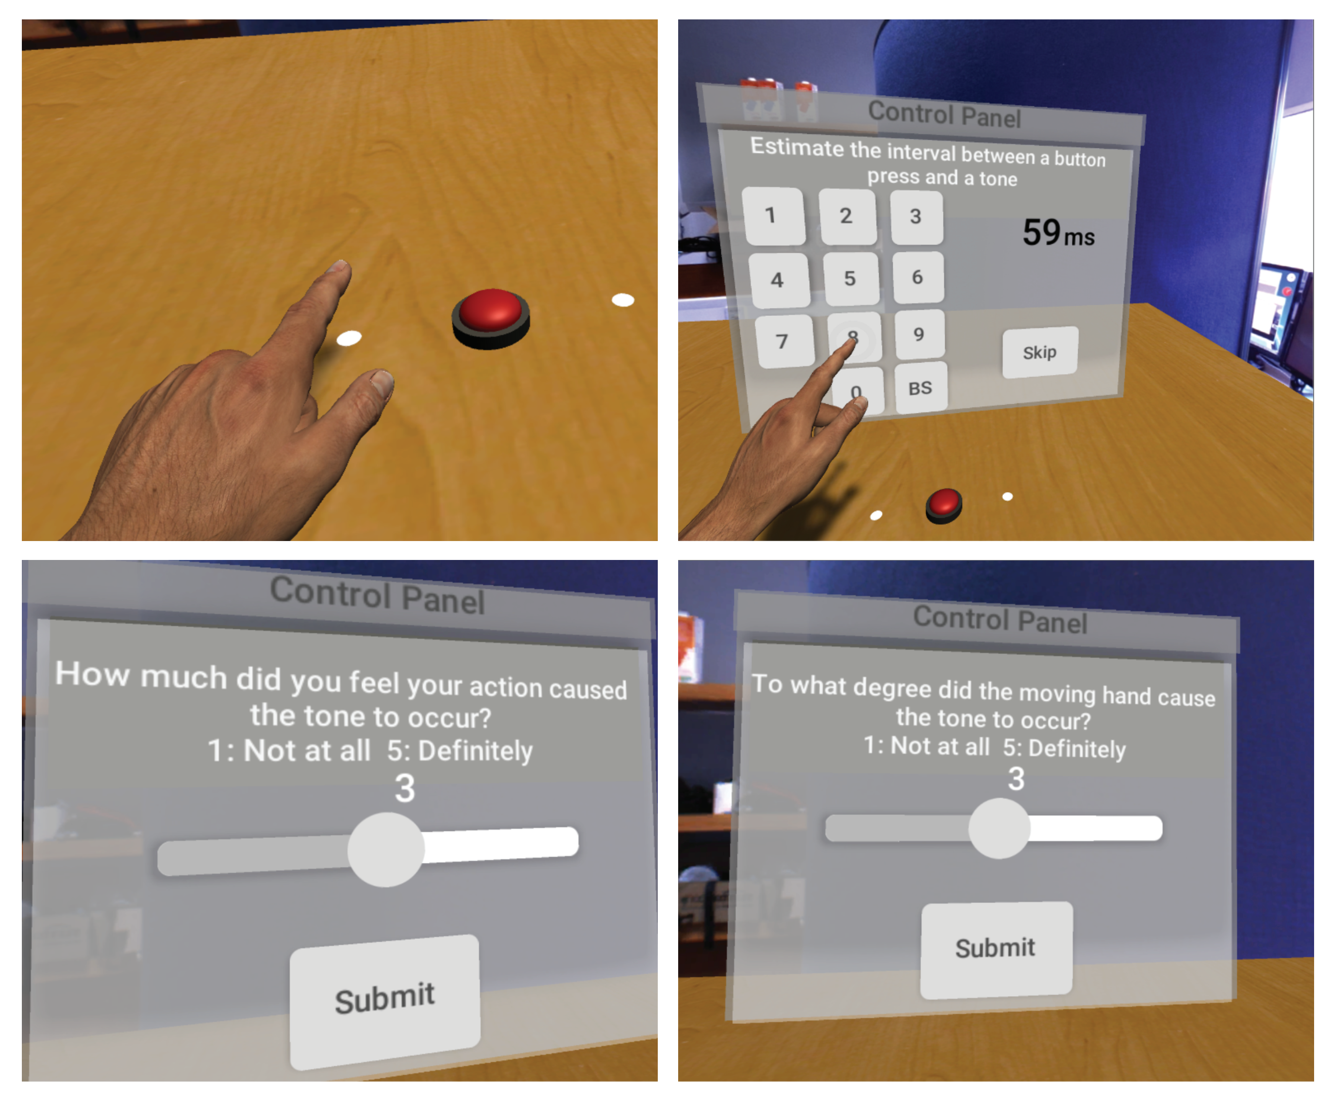
Figure 2. Participants’ view during different phases of the experiments. Top-Left: Hand reaching to press the button. Top-Right: Response panel for interval estimation task in Experiment 1. Bottom-Left: agency response panel in Experiment 2. Bottom-Right: Causality response panel in Experiment 2.

Experiment 3
The procedure in Experiment 3 was identical to Experiment 1 except that only Active and No Hand blocks were presented. Because of the absence of Fake blocks, no practice block in which hand movements were recorded (as in Experiment 1) were necessary. The order of the Active and No Hand blocks was counterbalanced across participants.

Statistical analyses
We assessed strength of evidence for effects with 1 degree of freedom using Bayes factors (BFs). This allowed us to infer not only if there is sensitive evidence in favour of the experimental hypothesis, but also to interpret evidence in favour of null hypothesis or conclude that the data are insensitive for a given contrast. A Bayes factor greater than 3 indicates sensitive evidence for the experimental hypothesis and a Bayes factor smaller than 1/3 indicates sensitive evidence for the null hypothesis. Bayes factors in between these two thresholds (above 1/3 but below 3 indicate that the data were insensitive and therefore provide no evidence either way (see Dienes, 2014; Jeffreys, 1939). B_{H(0,x)} refers to a Bayes factor in which the experimental hypothesis was modeled as a half-normal distribution with a standard deviation of x (see Dienes, 2014); directional predictions can be modeled by a half-normal distribution with SD based on existing results. B_{N(0,x)} refers to a Bayes factor in which the experimental hypothesis was specified as a normal distribution with mean of 0 and a standard deviation of x. This was used for nondirectional predictions where a plausible effect size could be predicted. B_{U[min,max]} refers to a Bayes factor in which the experimental hypothesis was modeled as a uniform distribution from minimum to maximum. This was used where there was no specific prediction about effect size, but there was a known maximum possible effect. As an indication of the robustness of Bayesian conclusions, a robustness region is reported for each B. The robustness region provides the range of scales over which a conclusion would be qualitatively consistent with conclusion obtained (i.e. evidence supports the null hypothesis, the alternative hypothesis, or is insensitive) and is notated as RR [x1, x2] where x1 is the smallest SD supporting that conclusion and x2 the largest. For all frequentist statistics, Bonferroni correction for multiple comparisons was applied where appropriate.

Results

Experiment 1

Predictions
To examine whether equal magnitude temporal binding effects can be found with and without intentional action, we contrasted interval estimation between the condition with (Active) and the conditions without (Fake, No Hand) intentional action. A previous study by Caspar and colleagues (Caspar, Cleeremans, & Haggard, 2015) report the results of an experiment relevant to predictions here. In an intentional binding study using interval estimation, a robot hand which activated an outcome (by pressing a button) was triggered either by the participant’s intentional action or by the experimenter pressing upon their finger (passive action). Averaged interval estimation (the average of three levels: 200, 400 and 800 msec) was 122.5 msec longer when the robotic hand was activated by intentional action than by passive action. Based on this result, we predicted that the average interval estimate would be shorter in our condition that included intentional action (Active) versus each of the other conditions that did not (No Hand and Fake). We therefore calculated Bayes factors for directional predictions of differences between these conditions using a half-normal with an SD of 122.5 msec. For the comparison of the Fake versus No Hand conditions we made no directional prediction and therefore calculated a Bayes factor using a full normal with a mean of 0 and an SD of 122.5 msec.

Results
Figure 3 shows the average of 48 participants’ reported intervals for each presented interval (200, 400, 800 msec), in each condition (Active, No Hand, Fake). Following previous work (Caspar et al., 2015), we first conducted a 3x3 repeated measures ANOVA on the reported intervals with within-subject factors of the three experimental conditions (Active, No Hand, and Fake) and three presented intervals (200, 400, 800 msec). This analysis revealed a main effect of condition, (F(2, 94) = 7.213, p=0.001, η² = 0.133) and also, as expected if participants’ interval estimates increased with the physically presented interval, of interval (F(1.176,55.294) = 403.891, p<0.001, η² = 0.896, Greenhouse-Geisser corrected).

To examine the simple effects in the above analysis, we calculated the average of interval estimates across the three presented intervals, for each participant and condition, and conducted paired samples t-tests (again, as in Caspar et al., 2015). First, comparing Active versus No Hand conditions we predicted a longer average estimated interval to for the No Hand compared to the Active condition. Analysis supported this prediction (No Hand: 450.1, SD = 90.91; Active: 423.5, SD = 98.49; t(47) = 3.975, p < 0.001, one-tailed, Cohen’s d = 0.574; B_{H(0, 122.5)} = 282.35, RR [2, 7446]). The alternative hypothesis, that the average interval estimation in the No Hand condition was longer than in the Active condition, was ~282 times more likely than the null hypothesis that average interval estimates were the same between these two conditions. This difference between Active and No Hand conditions is consistent with previously reported intentional binding results (Caspar et al., 2015).

Next, we compared the No Hand and Fake conditions. If intentional binding effects are driven by knowledge of intention, and simple causal binding cannot produce effects of equal magnitude, we would expect there to be no (or only a small) difference between the No Hand and Fake conditions. However, in disagreement with this expectation, we found that the average interval estimate in the Fake condition was numerically similar to that for Active (Fake: 427.7, SD = 94.66) and that estimates in the No Hand and Fake conditions were different (t(47) = 2.925, p = 0.016, paired samples, two-tailed, Cohen’s d = 0.422; B_{N(0, 122.5)} = 4.25, RR [5.1, 175]). This result suggests that the alternative hypothesis, that average interval estimates differed between No Hand and Fake conditions, was more than 4 times more likely than the null hypothesis of no difference between conditions. As for the above comparison of Active and No Hand conditions, interval estimates in the Fake condition were shorter than in the No Hand condition.

Finally, we compared Fake and Active conditions. If causal binding cannot produce an effect of the same magnitude as intentional binding, we would expect to find evidence that estimates in the Fake condition, in which visual and tactile feedback is the same as the Active condition but contains no intention or movement, are longer than in the Active condition. Contrary to this prediction, there was evidence for no difference in estimated interval between Active and Fake conditions (t(47) = 0.569, p = 0.858, Cohen’s d = 0.082; B_{H(0, 122.5)} = .10, RR [36.5, ∞]). This result indicates that the null hypothesis, that average interval estimates were the same in Fake and Active conditions, was around 10 times more likely than the alternative hypothesis that average interval estimates would differ between conditions. This suggests that causal binding can produce an effect of the same magnitude as intentional binding.
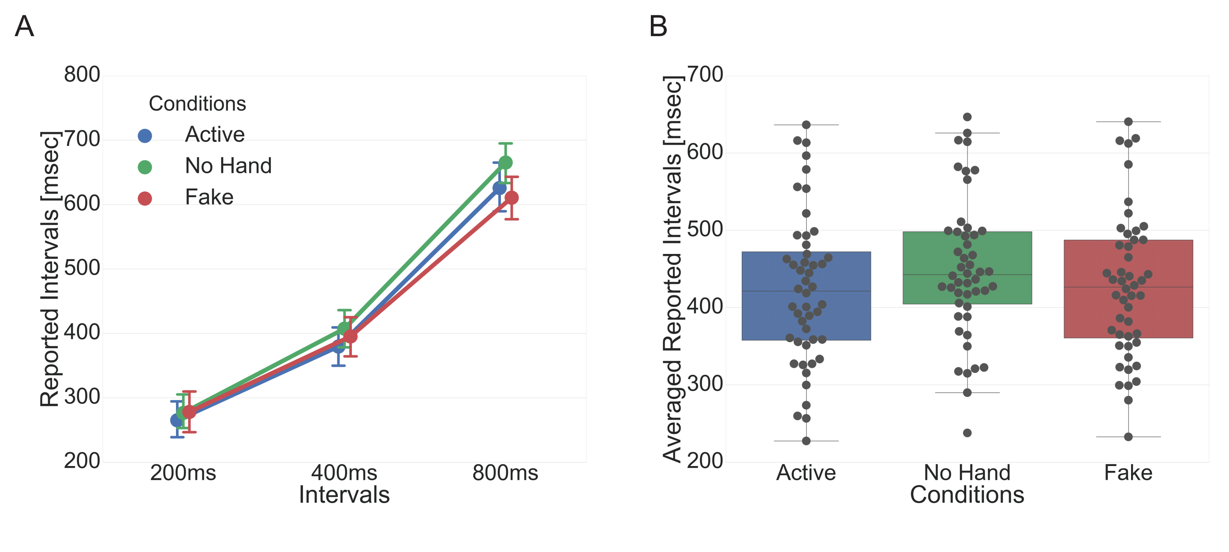
Figure 3. A) Average (N = 48) reported interval for each level of presented interval (200, 400 and 800 ms) in Active, No Hand, and Fake conditions in Experiment 1. Error bars indicate 95% confidence intervals. B) Average reported interval across three durations. Average reported interval was shorter in Active than No Hand trials, consistent with the presence of intentional binding in our VR setup. Average reported interval in Fake trials, in which participants made no intentional action but were given visual and tactile consistent with having done so, was also different from No Hand trials and the same as Active trials.

Experiment 2
The results of Experiment 1 indicated that the presence of only visual and tactile feedback of a button being pressed by a virtual hand (Fake condition) was sufficient to produce an equivalent magnitude temporal binding effect as when the participant actually pressed the button (Active condition). This suggests that the temporal binding effects under interval estimation designs typically used as evidence for intentional binding are not necessarily indicating anything more than temporal binding between apparently causally related events (Buehner, 2012, 2015; Buehner & Humphreys, 2009). Alternatively, as our Fake condition consists of replays of the participants’ own previous button-press movements, participants may have had a feeling of ownership over the hand presentations in the Fake condition such that intentional binding-like effects occur even in the absence of any intentional action. If participants experienced equivalent subjective agency in the Fake and Active conditions, this could account for the lack of difference in interval estimation between these conditions observed in Experiment 1. To verify that participants judgments of Fake and Active conditions truly differed in subjective agency, Experiment 2 tested explicit ratings of both agency and causality for the Fake and Active conditions.

Predictions
It has been established that intentional actions are associated with increased subjective agency than unintentional actions, when measured by explicit ratings of agency (e.g., Haggard, Cartledge, Dafydd, & Oakley, 2004; Lush et al., 2017). We therefore have a predicted direction of effect for the difference between Fake and Active conditions in explicit agency rating such that Active trials, in which participants do press the button, should elicit larger ratings of agency than Fake trials. In this experiment, we used a rating scale with a minimum rating of 1 and maximum rating of 5. We therefore calculated Bayes factors for this directional prediction of differences between conditions (Active larger than Fake) using a uniform distribution with minimum of 0 and maximum of 4; predicting a minimum difference between conditions in average rating of 0 (same rating in each condition) and maximum difference of 4 (Fake always given minimum rating, Active given maximum). For the causality ratings, we didn’t have an expected direction of difference and so calculated Bayes factors using a uniform distribution with a minimum of -4 and maximum of 4 (difference between conditions could fall anywhere between Fake being minimum and Active maximum rating, or vice versa).

Results
Figure 4A and 4C show the subjective ratings for agency and causality questions for each presented interval in each condition. Following the analysis structure as above for the interval estimation results, we conducted repeated measures ANOVAs for each task (Agency or Causality question) following up simple effects with paired samples frequentist and Bayesian t-tests.

A 2x3 repeated measures ANOVA was conducted on the Agency ratings in each condition (Active vs Fake) at the presented intervals (200, 400, 800msec). There were significant main effects for condition, F(1, 19) = 64.35, p<0.001, η² _{p} = 0.772, and interval, F(1.255, 23.846) = 30.97, p<0.001, η² = 0.62, Greenhouse-Geisser corrected. There was also a significant interaction of condition and interval, F(1.365, 25.942) = 19.99, p<0.001, η² = 0.513. A separate repeated measures ANOVA conducted on Causality ratings in each condition (Active vs Fake) at the presented intervals (200, 400, 800msec) revealed a significant main effect of interval, F(1.556, 29.560) = 43.466, p<0.001, η² = 0.696, Greenhouse-Geisser corrected. There was no evidence for an effect of condition, F(1, 19) = 0.001, p=0.979, η² = 3.7 x 10⁻⁵.

To investigate simple effects, we took the average of each participant’s rating for a given question and condition, across the three presented intervals. Figure 4B and 4D show the average rating for 20 participants, for each question (Agency or Causality) and condition (Active or Fake). Comparing the average reported agency between Active and Fake conditions, we predicted that agency should be higher in the Active than Fake condition. A Bayesian paired-samples t-test revealed evidence that this was the case (Fake: 2.10, SD = 1.04; Active: 4.00, SD = 0.52; t(19) = 8.02, p < 0.001, one-tailed, Cohen’s d = 1.79; B_{U(0, 4)} = 1.4x10¹³, RR [0, 4]). This result indicates that the alternative hypothesis, that there was a difference between agency reports in the Fake and Active conditions, was around 14 trillion times more likely than the null hypothesis that there was no difference.

In contrast to explicit judgements of agency, we had no directional predictions about the average reported causality between Active and Fake conditions. There was evidence for no difference in the average reported causality between Active and Fake conditions (Fake: 3.73, SD = 0.78; Active: 3.73, SD = 0.83; t(19) = 0.028, p = 0.978, paired samples, two-tailed, Cohen’s d = 0.006; , B_{U(-4, 4)} = 0.06, RR [-4, 4]). For the Causality rating the null hypothesis (of no difference in Causality ratings between Fake and Active conditions) was ~17 times more likely than the alternative hypothesis.
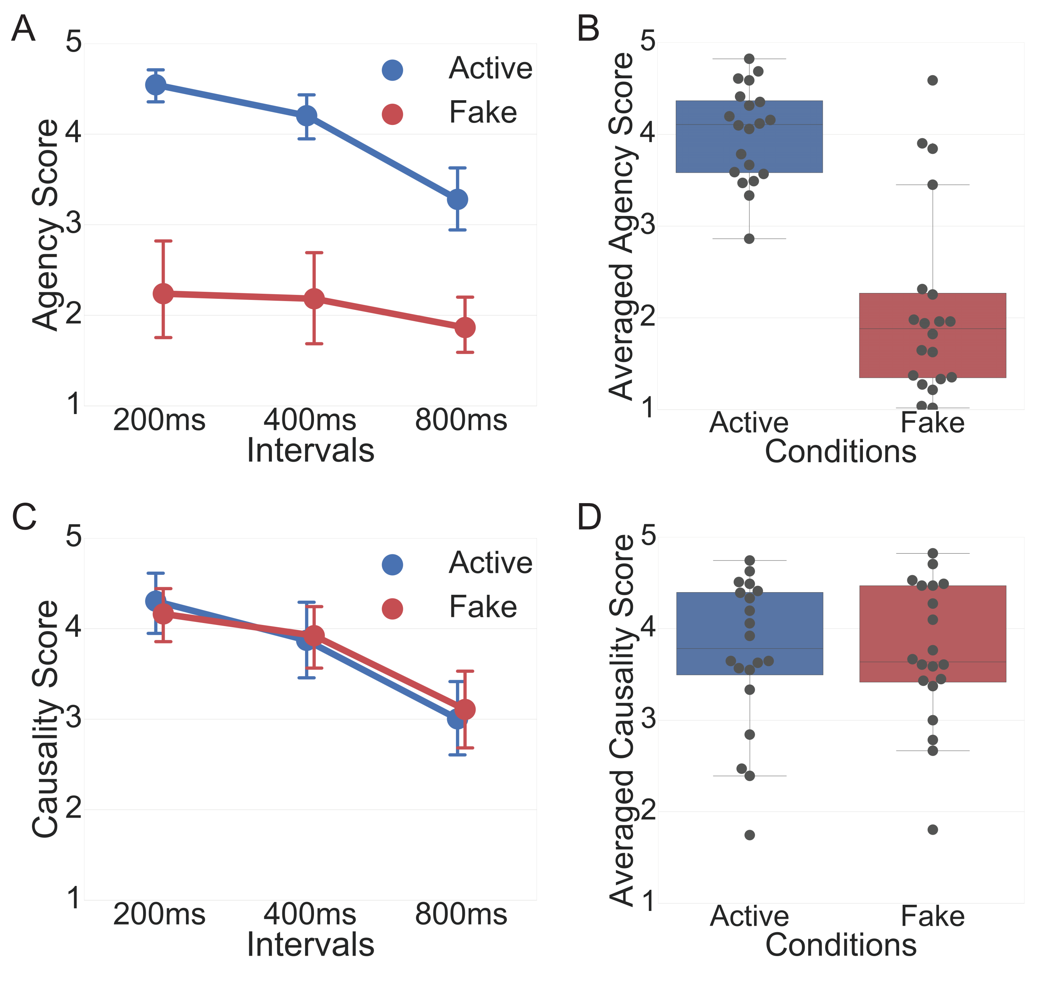
Figure 4. Subjective rating (1-5) for Agency (A, B) and Causality (C, D) questions for Active and Fake conditions. The A and C show that ratings separated by condition and interval, while the B and D show the rating averaged across intervals. The subjective rating was higher in the Active than the Fake condition when the question was about agency (A; “How much did you feel your action caused the tone to occur?”), whereas the rating did not differ between Active and Fake conditions when the question was more generally about causality (B; “To what degree did the moving hand cause the tone to occur?”). Error bars indicate 95% confidence intervals.

Experiment 3
The results of Experiment 1 provided clear evidence that intentional action is not required to obtain temporal binding effect of equivalent magnitude to that obtained in intentional binding studies. Experiment 2 showed that this result was could not be attributed to participants feeling agency over presentations of the virtual hand in the absence of intentional action. One possible criticism of these results might be that participants never truly felt that the virtual hand was their own. If participants never felt that the virtual hand belonged to them, it may have diminished the intentional binding effect in the Active condition, reducing the possible overall binding effect size and lead to similar binding effects in the Fake and Active conditions. The results of Experiment 2 indicate that this was unlikely to be the case as explicit ratings of agency were still strong, with ratings in the Active condition for short intervals near the maximum rating of the scale (5). Further, we note that the previously published results by Caspar and colleagues (Caspar et al., 2015), on which we based our expected effect size in analysing the results of Experiment 1, showed a large difference between active and passive conditions (average interval estimate difference of 122.5 msec between active and passive in their experiment). Although presented without any intermediate visual device, such as the head mounted display in our study, that study used an artificial hand presented in a displaced position from the participants’ hand. Such a setup certainly required some degree of belief by the participant regarding the potential for bodily ownership or control over an artificial hand and demonstrated large binding effects. Moreover, previous studies of the rubber-hand illusion and similar cases in VR have shown that typical metrics of bodily ‘ownership’ can be expressed for virtual body parts, particularly hands (IJsselsteijn, de Kort, Haans, & Kort, 2006; Slater, Perez-Marcos, Ehrsson, & Sanchez-Vives, 2008, 2009).
To provide evidence against the criticism that intentional binding using a virtual hand produces a reduced binding effect because of its virtual nature, we replicated Experiment 1 using an augmented rather than virtual reality setup. As outlined in the Methods, the setup for this experiment was identical to that described for Experiment 1 except for two features. Rather than participants viewing a virtual hand model that moved congruently with their hand movement, we showed participants their own arm, recorded through an eye-level mounted video camera against a green-screen and played through the head-mounted display in real time. Using this method, we could avoid any effect of incongruity that participants might have felt when viewing a virtual arm model. Because we were only interested in whether the magnitude of binding effect had been diminished by the virtual reality setup, in the augmented reality setup we only included the No Hand and Active conditions.

Predictions
To test whether there was evidence for intentional binding in our augmented reality setup, we compared average interval estimations between No Hand and Active conditions. In Experiment 1, we found that the averaged interval estimation (the average of three levels: 200, 400 and 800 msec) was 26.6 msec shorter when participants actively pressed the button (Active condition) versus when they simply observed the button depress by itself (No Hand). We therefore calculated Bayes factors for this directional prediction (Active vs No Hand) of differences between conditions using a half-normal with an SD of 26.6 msec.
Under a hypothesis that the magnitude of binding in the Fake condition was similar to the Active condition in Experiment 1 only because participants never truly thought the virtual hand belonged to them, we would expect that the magnitude of binding effect would be smaller in Experiment 1 than in Experiment 3, where participants viewed real time input of their actual hand moving. Again informed by results of (Caspar et al., 2015) we calculated Bayes factors for this directional prediction of differences between experiments (virtual reality binding smaller than augmented reality binding) using a uniform distribution with a minimum of 13.5 and maximum of 122.5 msec based on the fact that these were the smallest (active congruent versus control condition) and largest (active congruent versus passive congruent) differences between conditions reported in that study (Caspar et al. 2015; section Interval Estimation, page 228) and therefore represent the reasonable range of differences in magnitude of binding effect that might be expected between our virtual (Experiment 1) and augmented (Experiment 3) results.

Results
Analyses are similar to those reported for Experiment 1. Figure 5A shows average reported intervals for each presented interval in Active and No Hand conditions for the AR hand. A 2x3 repeated measures ANOVA with within-subject factors of condition (Active and No Hand) and presented intervals (200, 400, 800msec) was conducted. There were significant main effects for condition, F(1,29) = 6.893, p=0.014, η² = 0.192, and interval, F(1.085,31.464) = 215.918, p<0.001, η² = 0.882, Greenhouse-Geisser corrected.

Examining the simple effects, we again took the average of interval estimates across the three presented intervals, for each participant and condition, and conducted paired samples t-tests. Comparing Active versus No Hand conditions, as outlined in the Predictions section above, based on previous intentional binding results we expected the average estimated interval to be longer in the No Hand than Active condition. There was evidence that this was the case (No Hand: 436.2, SD = 100.3; Active: 406, SD = 99.4; t(29) = 2.604, p = 0.007, paired samples, one-tailed, Cohen’s d = 0.475; B_{H(0, 26.6)} = 13.667, RR [5.7, 225.9]). This difference between Active and No Hand conditions is again consistent with the presence of an intentional binding effect, this time in our augmented reality setup (rather than the previous VR setup).

To directly compare the magnitude of binding effect in the results from Experiment 1 using virtual reality with those from Experiment 3 where we used an augmented reality presentation, we compared the magnitude of binding effect (No Hand minus Active average interval estimate) between the two experiments. Based on the hypothesis that participants may have felt less agency over the hand model in virtual reality (Experiment 1) than in augmented reality (Experiment 3), we expected the binding effect to be smaller in the Experiment 1 results than those for Experiment 3. Contrary to this hypothesis, a Bayesian paired samples t-test revealed evidence for no difference between binding effects (VR binding: 26.6, SD = 46.38; AR binding: 30.2, SD = 63.5; t(76) = 0.287, p = 0.387, independent samples, one-tailed, Cohen’s d = 0.067; B_{U(13.5, 122.5)} = 0.064, RR [0, ∞]).
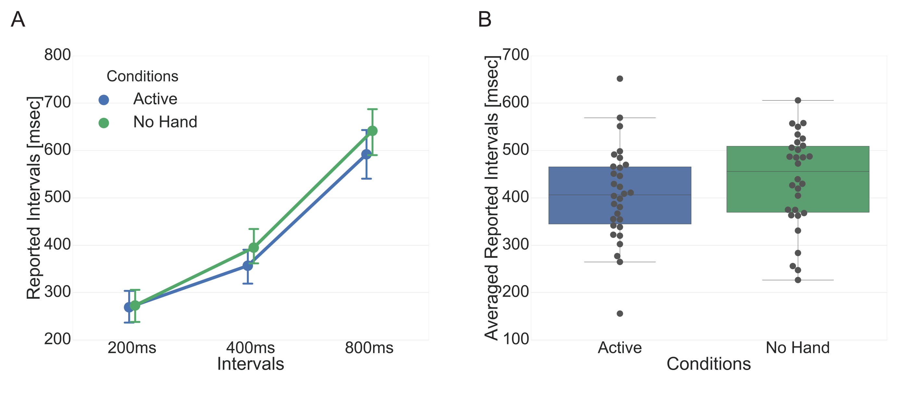
Figure 5. A) Average (N = 30) reported interval for each level of presented interval (200, 400 and 800 msec) in Active and No Hand conditions in Experiment 2. Error bars indicate 95% confidence intervals. B) Average reported interval across three presented durations. Mean reported interval was shorter in Active than No Hand trials, consistent with intentional binding being observed in our AR setup.

Discussion
We investigated temporal binding between a button press and an outcome tone when the button was pressed by the participant controlling or simply observing a virtual hand press the button, or when the button moved by itself. When the button moved by itself, binding was smaller than that produced by voluntary action. Such a result might typically be interpreted as evidence for intentional binding. However, comparing two conditions in which the virtual hand pressed the button – one in which the hand precisely tracked participants’ intentional movements, the other simply replaying the sensory content of previous button-presses without any participant action - there was no difference in binding. Explicit reports of agency did not match this pattern: participants reported higher agency over the controlled than merely observed virtual hand. These results provide the first statistically supported evidence for no difference in the magnitude of intentional and causal binding when conditions control for all information except internal signals (e.g., intention or proprioception).
These results underline the importance of considering the influence of causal relationships when interpreting binding results (Buehner, 2012, 2015). Intentional binding is often interpreted as a measure of sense of agency (Moore & Obhi, 2012). Such claims often rely only on previous studies which report an influence of intention to draw a link between binding and sense of agency, but this may result in inaccurate inferences. For example, if we assume binding reflects sense of agency, we might interpret the current results as demonstrating that participants have a sense of agency over an observed action (because we find the same magnitude of ‘intentional binding’ in the Fake condition), but that the type of sense of agency reflected in binding dissociates from explicit sense of agency. However, we should first consider the more parsimonious explanation that binding effects don’t necessarily reflect sense of agency. In-principle protection for the position that binding reflects agency has previously been provided by the fact that binding effects for non-intentional conditions have never produced a similar magnitude effect to those from intentional action conditions (e.g., Buehner, 2015). Our present results demonstrate that such a position is no longer defensible.
It has been argued that intentional binding may be driven by cross-modal cue combination (Kawabe et al., 2013; Wolpe, Haggard, Siebner, & Rowe, 2013, Lush, Roseboom, Cleeremans, Seth, Scott & Dienes, 2018), with the estimate of action or outcome event timing a precision-weighted estimate of both. One source of precision for action timing may arise from information related to motor-intentions and this may account for the contribution of intentional action to the magnitude of binding (Lush et al., 2017, 2016; Lush & Dienes, 2018). Poonian & Cunnington, (2013) report reduced binding when a button moved by itself compared to when the button was pressed by an observed arm (orthogonal to the participant). While the authors argued against a cue combination mechanism, a parsimonious explanation for this result is that arm movement preceding the button press provides a visual cue which increases the precision of action timing. This is likely to apply to the results presented here; specifically, in our VR setup with the arm movement in the first person perspective, visual information may be more reliable than other sources of information (e.g., motor intentions or proprioception) and the contribution of intention-related information over and above causal binding in such a case may be minimal enough to be undetectable by interval estimation. Thus, a cue combination mechanism can account for these results without appealing to changes in the sense of agency. Note that this does not imply that temporal binding never reflects sense of agency, merely that intention is not necessary for causal binding of the same magnitude as intentional binding.
Intentional binding in a VR environment can generate binding effects of equal magnitude to causal binding arising from merely observed action. Intentional binding research must account for the magnitude of causal temporal binding before relating temporal binding to the sense of agency.

Author Contributions
K.S and W.R. developed the study concept. K.S., P.L., and W.R. contributed to the study design. K.S. developed the experiment platform and performed testing and data collection. K.S., P.L., and W.R. performed the data analysis and interpretation. K.S., P.L., and W.R. drafted the manuscript, and A.S provided critical revisions. All authors approved the final version of the manuscript for submission.

Acknowledgements: Thanks to Rachel Bedder, Michaela Klimova, Dagmara Kołakowska, and Evka Phanvanova for assistance with data collection. This work was supported by the Dr Mortimer and Theresa Sackler Foundation, the EU FET Proactive grant TIMESTORM: Mind and Time: Investigation of the Temporal Traits of Human-Machine Convergence, and Canadian Institute for Advanced Research (CIFAR) Azrieli Programme on Brain, Mind, and Consciousness

References
Buehner, M. J. (2012). Understanding the Past, Predicting the Future. Psychological Science, 23(12), 1490–1497. http://doi.org/10.1177/0956797612444612
Buehner, M. J. (2015). Awareness of voluntary and involuntary causal actions and their outcomes. Psychology of Consciousness: Theory, Research, and Practice, 2(3), 237–252. http://doi.org/10.1037/cns0000068
Buehner, M. J., & Humphreys, G. R. (2009). Causal Binding of Actions to Their Effects. Psychological Science, 20(10), 1221–1228. http://doi.org/10.1111/j.1467-9280.2009.02435.x
Caspar, E. A., Christensen, J. F., Cleeremans, A., & Haggard, P. (2016). Coercion Changes the Sense of Agency in the Human Brain. Current Biology, 26(5), 585–592. http://doi.org/10.1016/j.cub.2015.12.067
Caspar, E. A., Cleeremans, A., & Haggard, P. (2015). The relationship between human agency and embodiment. Consciousness and Cognition, 33, 226–36. http://doi.org/10.1016/j.concog.2015.01.007
Desantis, A., Hughes, G., & Waszak, F. (2012). Intentional Binding Is Driven by the Mere Presence of an Action and Not by Motor Prediction. PLoS ONE, 7(1), e29557. http://doi.org/10.1371/journal.pone.0029557
Dienes, Z. (2014). Using Bayes to get the most out of non-significant results. Frontiers in Psychology, 5, 781. http://doi.org/10.3389/fpsyg.2014.00781
Engbert, K., Wohlschläger, A., Thomas, R., & Haggard, P. (2007). Agency, subjective time, and other minds. Journal of Experimental Psychology. Human Perception and Performance, 33(6), 1261–8. http://doi.org/10.1037/0096-1523.33.6.1261
Haggard, P. (2017). Sense of agency in the human brain. Nature Reviews Neuroscience, 18(4), 196–207. http://doi.org/10.1038/nrn.2017.14
Haggard, P., Cartledge, P., Dafydd, M., & Oakley, D. A. (2004). Anomalous control: When ‘free-will’ is not conscious. Consciousness and Cognition, 13(3), 646–654. http://doi.org/10.1016/j.concog.2004.06.001
Haggard, P., Clark, S., & Kalogeras, J. (2002). Voluntary action and conscious awareness. Nature Neuroscience, 5(4), 382–385. http://doi.org/10.1038/nn827
IJsselsteijn, W. A., de Kort, Y. a. W., Haans, A., & Kort, Y. A. W. de. (2006). Is This My Hand I See Before Me? The Rubber Hand Illusion in Reality, Virtual Reality, and Mixed Reality. Presence: Teleoperators and Virtual Environments, 15(4), 455–464. http://doi.org/10.1162/pres.15.4.455
Jeffreys, H. (1939). The Theory of Probability. Oxford University Press.
Kawabe, T., Roseboom, W., & Nishida, S. (2013). The sense of agency is action-effect causality perception based on cross-modal grouping. Proceedings of the Royal Society B: Biological Sciences, 280(1763), 20130991–20130991. http://doi.org/10.1098/rspb.2013.0991
Khalighinejad, N., Di Costa, S., & Haggard, P. (2016). Endogenous Action Selection Processes in Dorsolateral Prefrontal Cortex Contribute to Sense of Agency: A Meta-Analysis of tDCS Studies of ‘Intentional Binding.’ Brain Stimulation, 9(3), 372–379. http://doi.org/10.1016/j.brs.2016.01.005
Lush, P., Caspar, E. A., Cleeremans, A., Haggard, P., Magalhães De Saldanha da Gama, P. A., & Dienes, Z. (2017). The Power of Suggestion: Posthypnotically Induced Changes in the Temporal Binding of Intentional Action Outcomes. Psychological Science, 28(5), 661–669. http://doi.org/10.1177/0956797616687015
Lush, P., & Dienes, Z. (2018). Time perception and the experience of agency in meditation and hypnosis. PsyArxiv. http://doi.org/10.31234/OSF.IO/MH7ET
Lush, P., Roseboom, W., Cleeremans, A., Scott, R. B., Seth, A., & Dienes, Z. (2018). Intentional binding as Bayesian cue combination: testing predictions with trait individual differences. https://doi.org/10.31234/osf.io/4jm3a
Lush, P., Parkinson, J., & Dienes, Z. (2016). Illusory Temporal Binding in Meditators. Mindfulness, 7(6), 1416–1422. http://doi.org/10.1007/s12671-016-0583-z
Moore, J. W., Lagnado, D., Deal, D. C., & Haggard, P. (2009). Feelings of control: contingency determines experience of action. Cognition, 110(2), 279–83. http://doi.org/10.1016/j.cognition.2008.11.006
Moore, J. W., & Obhi, S. S. (2012). Intentional binding and the sense of agency: A review. Consciousness and Cognition, 21(1), 546–561. http://doi.org/10.1016/j.concog.2011.12.002
Poonian, S. K., & Cunnington, R. (2013). Intentional binding in self-made and observed actions. Experimental Brain Research, 229(3), 419–427. http://doi.org/10.1007/s00221-013-3505-5
Slater, M., Perez-Marcos, D., Ehrsson, H. H., & Sanchez-Vives, M. V. (2008). Towards a digital body: the virtual arm illusion. Frontiers in Human Neuroscience, 2, 6. http://doi.org/10.3389/neuro.09.006.2008
Slater, M., Perez-Marcos, D., Ehrsson, H. H., & Sanchez-Vives, M. V. (2009). Inducing illusory ownership of a virtual body. Frontiers in Neuroscience, 3(2), 214–20.
Wolpe, N., Haggard, P., Siebner, H. R., & Rowe, J. B. (2013). Cue integration and the perception of action in intentional binding. Experimental Brain Research, 229(3), 467–74. http://doi.org/10.1007/s00221-013-3419-2

